





**Construction Standard Application**

**Quick Guide Instructions for**

**Iowa EASY Air**

Iowa Department of Natural Resources

Wallace State Office Building

Air Quality Bureau

502 E 9th St

Des Moines, IA 50319

Phone: (515) 725-8200

**Contact the Iowa EASY Air Helpdesk**

**Email:** [**easyair@dnr.iowa.gov**](mailto:easyair@dnr.iowa.gov)

**Or call (515) 725-9569 or (515) 204-3749**

# Table of Contents

Table of Contents 2

List of Figures 3

1. Adding the Construction Standard Application to Your Account 5

2. Finding the Construction Standard Application 8

3. Filling Out and Submitting a Construction Standard Application 9

3.1 Basic Application Navigation 10

3.2 Facility Information 11

3.3 Cover Page 13

3.3.1 Company Description 13

3.3.2 Application Description 13

3.4 Emission Point 15

3.4.1 Adding a New Emission Point 16

3.4.2 Modifying an Existing Emission Point 18

3.4.3 Deleting an Emission Point 18

3.4.4 Copying an Emission Point 18

3.4.5 Other Emission Point Table Functionality 19

3.4.6 Finishing Up 19

3.5 Control Equipment 19

3.5.1 Adding a New Control Equipment Device 19

3.5.2 Miscellaneous/General Control Equipment Form Information 21

3.5.3 Catalytic & Non-Catalytic Reduction 22

3.5.4 Catalytic Oxidation 23

3.5.5 Cyclones 24

3.5.6 Dry Filter 24

3.5.7 Fabric Filters 24

3.5.8 Mist Eliminator 24

3.5.9 Thermal Oxidation 24

3.5.10 Wet or Dry Scrubber 25

3.5.11 Associating Controlled Pollutants 25

3.5.12 Associating Emission Points 27

3.5.13 Modifying Existing Control Equipment 27

3.5.14 Deleting Control Equipment 28

3.5.15 Copying Control Equipment 28

3.5.16 Other Control Equipment Functionality 28

3.5.17 Finishing Up 29

3.6 Emission Unit 29

3.6.1 New Emission Units 29

3.6.2 Miscellaneous/General Emission Unit Form Information 31

3.6.3 Cooling Tower 34

3.6.4 Boiler 34

3.6.5 Internal Combustion Engine 35

3.6.6 Nonmetallic Mineral Processing Plant 37

3.6.7 Spray Paint Booth 38

3.6.8 Associating Control Equipment 40

3.6.9 Associating Emission Points 40

3.6.10 Modifying Existing Emission Units 41

3.6.11 Deleting Emission Units 41

3.6.12 Copying Emission Units 42

3.6.13 Other Emission Unit Functionality 42

3.6.14 Finishing Up 43

3.7 Emission Calculations 43

3.7.1 Adding New Emission Calculation Information 43

3.8 Emission Inventory 46

3.8.1 Permitted or Potential Stack/Vent Emissions Summary 46

3.8.2 Permitted or Potential Fugitive Emissions Summary 48

3.8.3 Exempt or Grandfathered Source Emissions Summary 48

3.9 Greenhouse Gas Emission Inventory 48

3.10 Non-PSD Modeling Determination 50

3.11 Form AF (Application Fee) 55

3.12 Attachments 55

3.13 Validation 57

3.14 Payment 57

3.15 Submission 58

# List of Figures

Figure 1 Dashboard Buttons to Create a New Submittal 5

Figure 2 Submittal Menu 5

Figure 3 Link to Submittal Types Associated with my Account 6

Figure 4 Available Submittal Types 6

Figure 5 My Account Menu 7

Figure 6 Basic Information Tabs 7

Figure 7 Associate Facility Button 7

Figure 8 Associate Facility Search 8

Figure 9 Facility Search Results and Adding Submission Type 8

Figure 10 Dashboard Buttons to Create a New Submittal 9

Figure 11 Submittal Menu 9

Figure 12 Construction Standard Application Icon 9

Figure 13 Form Navigation Buttons 10

Figure 14 Wizard Panel 10

Figure 15 Incomplete Emission Unit Example 11

Figure 16 Reason for Application, Facility Name, and Contact Person Summary 12

Figure 17 Equipment Location and Mailing Contact Summary 12

Figure 18 Application Description Summary 14

Figure 19 SIC/NAICS Code Search Example 14

Figure 20 Emission Point Information Table Example 16

Figure 21 Emission Point Information Example 16

Figure 22 Emission Point Modification Example 18

Figure 23 Copying an Emission Point Example 18

Figure 24 Copying an Emission Point Example 18

Figure 25 Control Equipment Table Example 19

Figure 26 Control Equipment Data Entry Example 20

Figure 27 Miscellaneous Control Equipment Types 21

Figure 28 Associate Controlled Equipment Screen 25

Figure 29 Criteria Air Pollutant Codes 26

Figure 30 “Other” Pollutant Codes 26

Figure 31 Associate Emission Point Screen 27

Figure 32 Control Equipment Modification Example 27

Figure 33 Copying a Control Equipment Entry Example 28

Figure 34 Copying a Control Equipment Entry Example 28

Figure 35 Emission Unit Table Example 29

Figure 36 Emission Unit Data Entry Example 30

Figure 37 Miscellaneous Emission Unit Types 31

Figure 38 Capacity Units of Measure 32

Figure 39 Emission Limit Table 33

Figure 40 Emission Limit Table Example 33

Figure 41 Air Emissions Diagram (Form EU-13A) Example 34

Figure 42 Boiler Fuel Burned Component Example 35

Figure 43 Engine Fuel Burned Component Example 37

Figure 44 Spray Gun Description and Specifications Table 38

Figure 45 Spray Material Description and Specifications Table 39

Figure 46 Material Usage Limits Table 40

Figure 47 Associate Control Equipment Screen 40

Figure 48 Associate Emission Point Screen 41

Figure 49 Emission Unit Modification Example 41

Figure 50 Copying an Emission Unit Entry Example 42

Figure 51 Copying an Emission Unit Entry Example 42

Figure 52 Add New Calculations Button 43

Figure 53 Emission Calculation Information Data Entry Example 43

Figure 54 Pollutant Code Search Field 44

Figure 55 Pollutant Code Search Results 45

Figure 56 Emission Inventory Screen Example 46

Figure 57 Emissions Summary Example 46

Figure 58 Project Greenhouse Gas Emission Inventory Information Summary 49

Figure 59 Non-PSD Modeling Information Example Screen 51

Figure 60 Availability of Air Resources Example Screen 52

Figure 61 Modeling Determination Example Screen 53

Figure 62 Form AF Screen 55

Figure 63 Example Attachment Screen 56

Figure 64 Upload Attachment Screen 56

Figure 65 Example Attachment Screen 56

Figure 66 Example Validation Screen 57

Figure 67 Example Payment Screen 58

Figure 68 Example Certificate of Submission Screen 58

Figure 69 Confirmation of Submittal 59

This document provides directions on how to apply for a construction permit using the Construction Standard Application in the Iowa EASY Air System.

(Note: This document is written to explain how a Responsible Official can apply for a construction permit using the Construction Standard Application. As with other submittal types within the Iowa EASY Air system, the Responsible Official may delegate the completion of these forms to a Preparer. The Preparer can complete the forms and have the Responsible Official complete the certification and submit the application. The instructions for assigning a Preparer for a facility and submittal type are covered in other parts of the Iowa EASY Air documentation.)

# Adding the Construction Standard Application to Your Account

Before you are able to apply for a construction permit using the Construction Standard Application in the Iowa EASY Air system, you will need to add the Construction Standard Application to your account.

**Viewing Associated Application Types**

If you do not know what application types are associated to your account, you may navigate to the Air Department Submittal Type List page and view the submittal types associated with your account. There are two ways to the Air Department Submittal Type List page within the Iowa EASY Air system.

For one method, on your dashboard click on the “Apply for a New Submittal” button in the upper left-hand corner of the dashboard as shown in Figure 1.

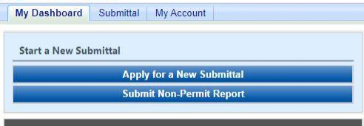

Figure 1 Dashboard Buttons to Create a New Submittal

Alternatively, hover over the Submittal dropdown menu and select “Start a New Submittal” as shown in Figure 2.

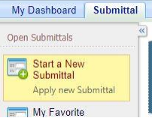

Figure 2 Submittal Menu

Next, you will see the application icons for the different types of submittals available to you in the system as shown in Figure 3.

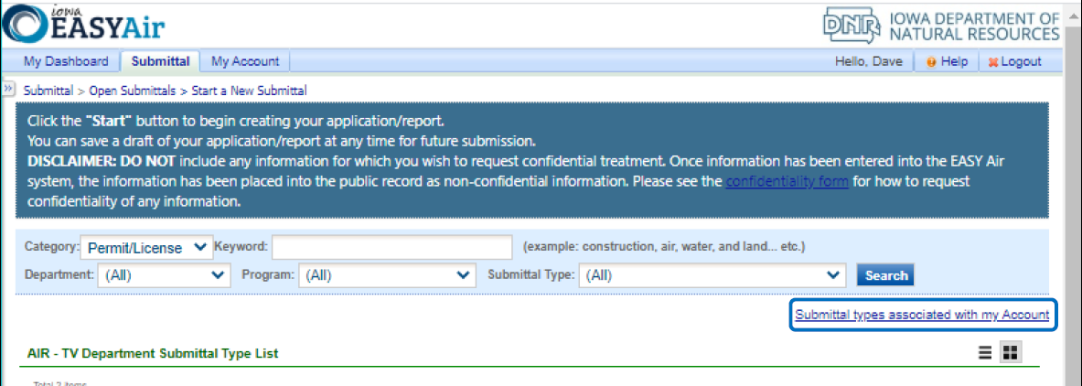

Figure 3 Link to Submittal Types Associated with my Account

Next, click on the link labeled “Submittal types associated with my Account” on the right side of the screen and the “Available Submittal Types” screen will appear as shown in Figure 4. On this screen, you are able to view the available submittal types and the submittal types already associated with your account.

A screenshot of the "Available Submittal Types". Two sections are shown, the "Available Submittal Types" and "Submittal Type Association Instruction".

Figure 4 Available Submittal Types

If you don’t see the Construction Standard Application associated with your account, click on “Add More”. This will take you to the “Basic Information” page. Follow the instructions below to associate the application type.

**Associate an Application Type**

To associate an application type to your account, you will need to navigate to the “Associate Facilities” tab. To navigate to the “Associate Facilities” tab, on your dashboard hover on “My Account” and click on “Basic Information” as shown in Figure 5.

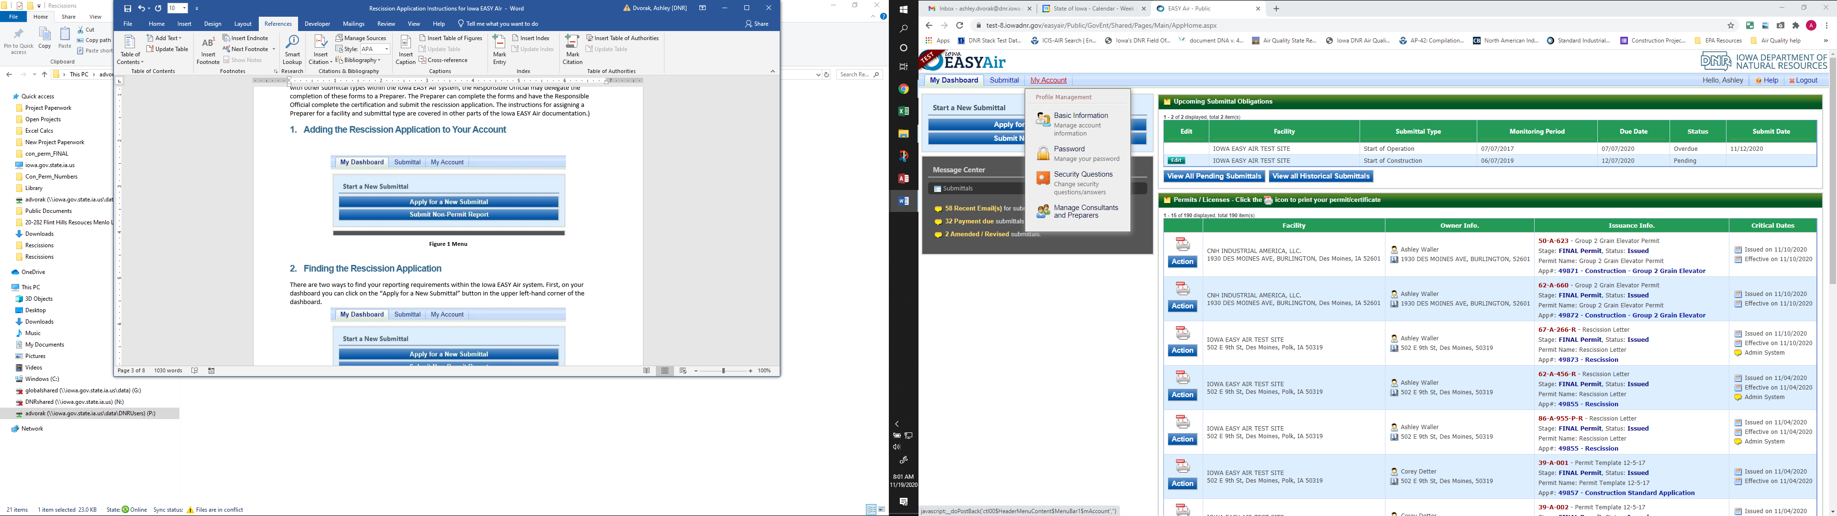

Figure 5 My Account Menu

The Basic Information page will appear. As shown in Figure 6, this page will have four tabs on top. Click on the “Associate Facilities” tab. This tab will show all of your associated facilities and application types you currently have on your account.

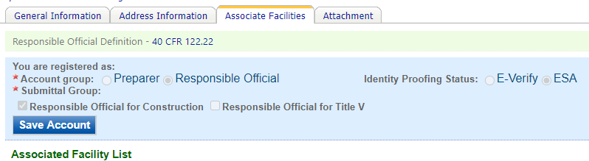

Figure 6 Basic Information Tabs

Next, scroll to the bottom of the page and you should see three buttons, as shown in Figure 7 below. Please click on “Associate Facility”.

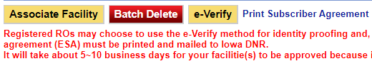

Figure 7 Associate Facility Button

The facility search will appear as shown in Figure 8 below. Enter in your facility information and click, “Search”. You may search by Facility Name, Address, or Facility Number.

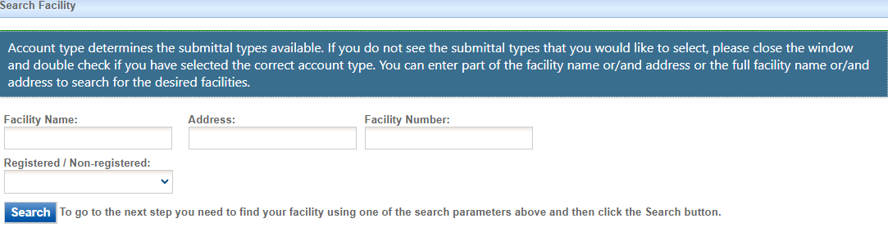

Figure 8 Associate Facility Search

The facility information will appear below the facility search as shown in Figure 9. Select the check box for the facility and the “Construction Standard Application” check box under submission type.

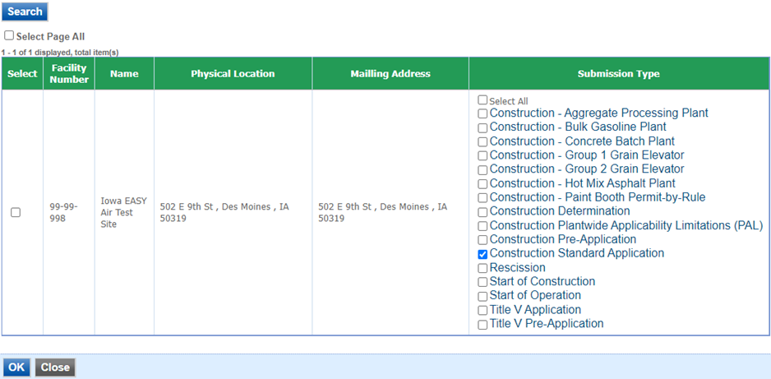

Figure 9 Facility Search Results and Adding Submission Type

Next, click “Ok” and then click “Close”. This will associate the Construction Standard Application application to your account. If you went through the e-Verify subscriber agreement process when you set up your account, you will be able to use the Construction Standard Application after this step. However, if you sent in the paper subscriber agreement form, you will have to wait until the Iowa EASY Air Administrator completes the association of the Construction Standard Application to your account. You will receive an email from the Iowa EASY Air Administrator when the association of the Construction Standard Application has been made to your account.

# Finding the Construction Standard Application

There are two ways to start an application within the Iowa EASY Air system. For one method, on your dashboard you can click on the “Apply for a New Submittal” button in the upper left-hand corner of the dashboard as shown in Figure 10.



Figure 10 Dashboard Buttons to Create a New Submittal

Alternatively, hover over the “Submittal” tab and select “Start a New Submittal” as shown in Figure 11.



Figure 11 Submittal Menu

Next, you will see the application icons for the different types of submittals available to you in the system. The Construction Standard Application icon is shown below in Figure 12. Please select “Start” at the bottom right hand corner of the icon to start the Construction Standard Application.



Figure 12 Construction Standard Application Icon

# Filling Out and Submitting a Construction Standard Application

According to 567 Iowa Administrative Code (IAC) 22.1(1):

“Unless exempted in subrule 22.1(2) …, no person shall construct, install, reconstruct or alter any equipment, control equipment or anaerobic lagoon without first obtaining a construction permit…

A permit shall be obtained **prior to** the initiation of construction, installation, or alteration of any portion of the stationary source or anaerobic lagoon.” (Emphasis added)

New, reconstructed, or modified sources may initiate construction prior to issuance of the construction permit by the department if they meet the eligibility requirements at 567 IAC 22.1(1)”c”.

The Department issues an individual Air Quality Construction Permit for each emission point in the project. Each permit addresses all emission units venting to that emission point. All permits will be issued simultaneously at the completion of the project review.

The Construction Standard Application should be used for any proposed equipment outside of general template permits (aggregate processing, hot mix asphalt, concrete batch, gasoline bulk, or group 2 grain elevator plants), or registration style permits (paint booth permit by rule or group 1 grain elevators). The Iowa EASY Air application for a Construction Standard Application has been designed to guide you through completing an application and verifying that all the required information is included to ensure a timely and complete review. Additionally, the Iowa EASY Air application will save equipment information within the system for use in future projects or modification requests.

## Basic Application Navigation

You may navigate through the Construction Standard Application using the navigation buttons on each screen (See Figure 13) or the Wizard Panel (See Figure 14).

An example screenshot of the navigation buttons, with Exit, Save, Previous, and Next listed in order from left to right.

Figure 13 Form Navigation Buttons

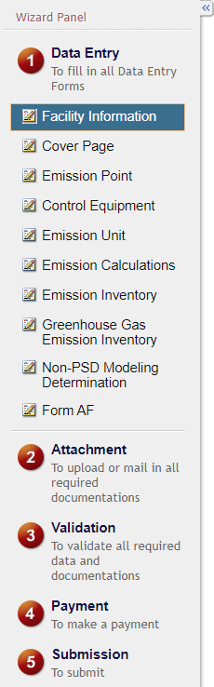

Figure Wizard Panel

Selecting “Exit” will take you out of the Construction Standard Application and will take you back to the “Edit Pending Submittals” screen.

Selecting “Save” will save your current progress on the current application form you are working on. The system will not “commit” any of the information entered on the screen or within any of the entries on a screen without selecting this “Save” button.

Selecting the “Previous” or “Next” buttons will take you to the either the previous or next form, as shown in the Wizard Panel.

Always select “Save” prior to selecting the navigation buttons to ensure your work is saved within the system.

You may also navigate to any of the forms or steps in the application by clicking on the form or step of the application in the Wizard Panel.

If you did not complete all the required fields for any form, the system will give a warning that the field or the form is incomplete, similar to the one shown below in Figure 15:

A screenshot of an example error, which is a red box with a large "X" that states what the error is with the current form.

Figure 15 Incomplete Emission Unit Example

This will appear in the final “Validation” step in the application process. If you do not have all the information at the time to complete part of your application, you may fill out what you can and return to that part of the application at any time. You may also use the Wizard Panel to jump to any part of the application to complete unfinished forms.

Please note that the system will not allow you to submit an incomplete application based on the “Validation” step.

## Facility Information

Next, the Facility Information screen will appear (see Figure 16 and 17). Under the Reason for Application, please use the checkboxes to indicate the reason(s) for the application. Explanations for each reason are listed below for reference.

**New – Not Yet Constructed:** Check this box if the project includes new equipment that has not been constructed yet, and therefore does not have a construction permit associated with it.

**New – Already Constructed:** Check this box if the project includes new equipment that has already been constructed, in the event that the equipment does not have a construction permit associated with it. This checkbox should be used if a Notice of Violation (NOV) or Letter of Noncompliance (LNC) was issued to the facility for failure to obtain a construction permit, or if a previously exempt emission unit is being permitted as part of the project.

**Modification:** Check this box if the project includes existing (i.e., the equipment already has a construction permit associated with it) equipment that is being modified for whatever reason.

**Determination:** Check this box if part of your project includes a request for a determination from the Department on an aspect of construction permitting (i.e., is a construction permit required for a specific emission unit?).

**Rescission:** Check this box if you have included a letter to request to rescind a Prevention of Significant Deterioration (PSD) construction permit as part of the project. The Construction Standard Application should not be used to rescind non-PSD construction permits. There is a separate Rescission application type for rescinding non-PSD construction permits. Instructions for accessing this application type can be found on the Iowa DNR website at [Rescission Application Quick Guide Instructions for Iowa EASY Air](https://www.iowadnr.gov/portals/idnr/uploads/air/eAirServices/Rescission%20Application%20Instructions%20for%20Iowa%20EASY%20Air.pdf).

**Prevention of Significant Deterioration (PSD) Project or amendment to an existing PSD permit:** Check this box if any equipment in your project is subject to PSD review according to the rules set forth in 567 IAC – Chapter 33, or if you are amending an existing PSD permit.

Please click on the “Company/Facility Name:” dropdown menu and select the Company/Facility Name that the construction standard application should be completed for. The facility address, facility number, field office number, and current billing status will auto-fill. If the facility information is not correct, please contact [easyair@dnr.iowa.gov](mailto:easyair@dnr.iowa.gov) to change the facility information.

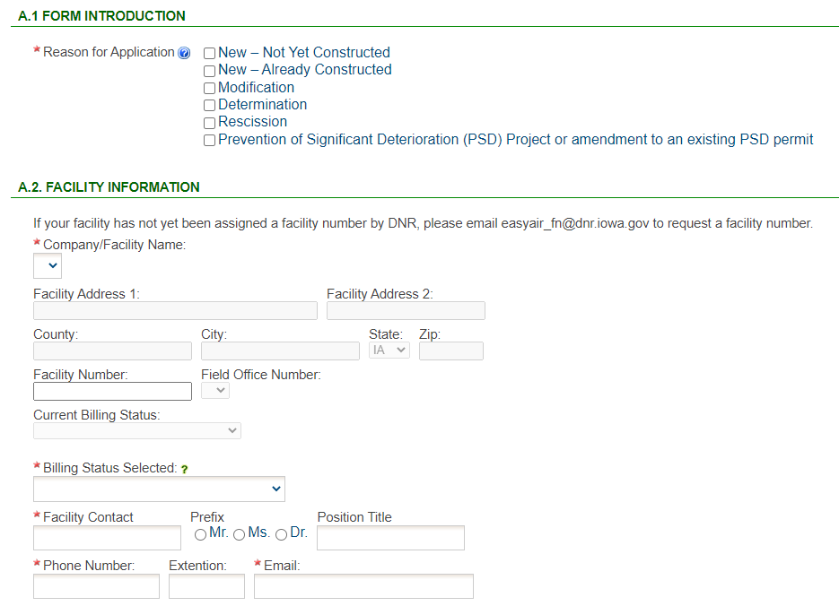

Figure 16 Reason for Application, Facility Name, and Contact Person Summary

The “Billing Status Selected:” field should be used to indicate the actual billing status for the facility if the “Current Billing Status” is incorrect. If the “Current Billing Status” is correct, please select the same billing status under “Billing Status Selected”. If you have any questions about your facility’s billing status or Air Quality Fees, please visit the DNR webpage [Air Quality Fees](https://www.iowadnr.gov/Environmental-Protection/Air-Quality/Air-Quality-Fees).

Please provide the name, position title, and contact information for the person within the company who should be contacted regarding questions or other pertinent information related to the construction standard application.

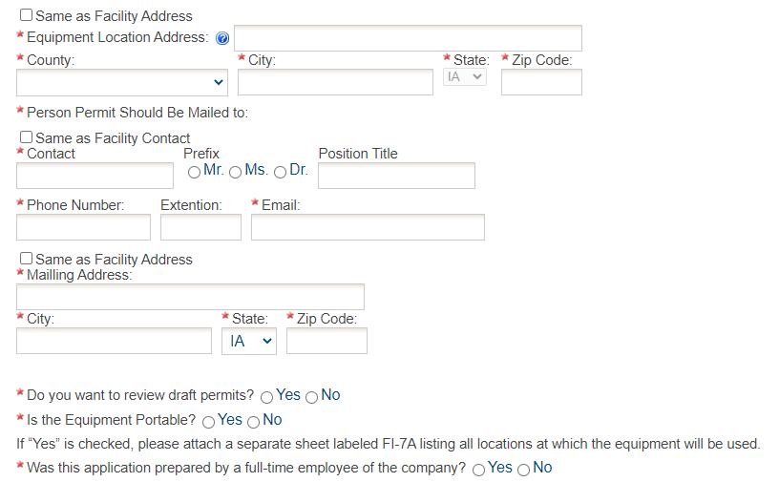

Figure 17 Equipment Location and Mailing Contact Summary

Please provide the address for where the equipment will be or is already installed. If the equipment is portable, please use the staging area address. If the equipment is located at the same address as the facility, select the “Same as Facility Address” checkbox, and the information will be copied from the facility address information.

Please provide the name, position title, contact information, and mailing address for the person within the company who should be mailed the final permits. If the person who should be mailed the final permits is the same person as the Facility Contact, select the “Same as Facility Contact” checkbox and the information will be copied from the facility contact information. If the mailing address for the person who should be mailed the final permits is the same as the facility address, select the “Same as Facility Address” checkbox and the information will be copied from the facility address information.

If you would like to review the draft permits, please select the “Yes” radio button. The Department offers a three (3) working day review period for reviewing draft permits if selected. The Department highly recommends reviewing the draft permits to ensure that the permits are accurate and complete prior to permit issuance to avoid any future modifications to the permits.

If the equipment is portable (such as a portable asphalt plant), please select the “Yes” radio button. If the portable equipment will be used in other locations, attach a separate sheet labeled FI-7A in the Attachments section to list all locations known at the time of application submittal.

If the application was prepared by a full-time employee of the company, please select the “Yes” radio button. If the application was not prepared by a full-time employee of the company, the permit preparer information must be filled out. Any permit preparer that is not a full-time employee of the company must be a licensed Professional Engineer (P.E.) in the State of Iowa (567 IAC 22.1(3)”b”). A P.E. signature document must also be attached to the submittal in the Attachments section. The P.E. number may be verified at the [License Search Page](https://iowaplb.force.com/LicenseSearchPage).

Once you have finished entering the information, click “Save” and then “Next”. If there is required information missing from the section, the Iowa EASY Air system will highlight the required fields in red. You may proceed with the application, but the system will not allow you to submit the application until all the required fields are completed during the Validation step.

## Cover Page

Next, the Cover Page screen will appear.

#### Company Description

Indicate whether you would like to either upload or type in a description of the company or the facility using the radio buttons. If you select “Upload”, the Company Description will become a required attachment at the end of the application in the Attachment screen. If you select “Type in”, the application will provide a text box to provide a description of the company/facility. Briefly describe the operations of your company. This description can include product(s) made and/or services provided, the company headquarters and size, subsidiaries of the company, and a website address for the company, etc. The purpose is to provide the review engineer with some background of the overall company.

#### Application Description

To save time during the review of your project, it is important to include a detailed application description so that the review engineer understands the goals or objectives of the permit request. Indicate whether you would like to either upload or type in a description of the application and the goals/objectives of the permit request using the radio buttons. If you select “Upload”, the Application Description will become a required attachment at the end of the application in the Attachment screen. If you select “Type in”, the application will provide a text box to provide a description of the application and the goals/objectives of the permit request.

Provide a description for the permit application(s) being submitted. Some of the possible reasons for the permit application(s) could be new equipment/process line, amending a permit based on a stack test, correcting a permit based on an inspection or Title V review, changing operating limits, or requesting permit limits to avoid a program (i.e. PSD, Title V, NESHAP, etc.). Please also describe any facility-wide operational limitations being requested as a part of this application.

Figure 18 below shows the application summary description.

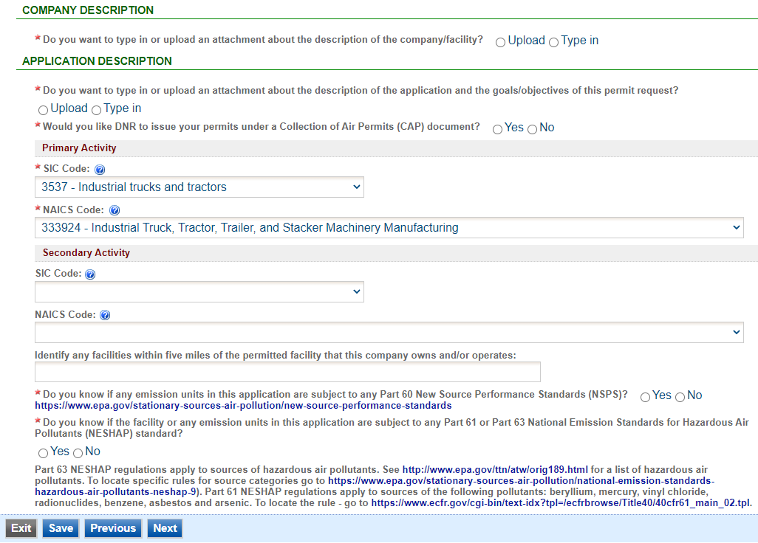

Figure 18 Application Description Summary

Please select whether you would like your permits to be issued under a Collection of Air Permits (CAP) document using the radio buttons. Information on CAPs can be found at [Construction Permitting Materials](https://www.iowadnr.gov/Environmental-Protection/Air-Quality/Construction-Permits/Construction-Permitting-Materials#258770-general-guidance) under the tab “General Guidance”, at the documents titled “Collection of Air Permits (CAP) Fact Sheet” and “CAP Frequently Asked Questions (FAQ)”.

**SIC and NAICS Codes – Industry Classification**

The Standard Industrial Classification (SIC) and North American Industrial Classification System (NAICS) codes are systems used for classifying industries and are used to determine a plant’s applicability to Federal regulations. Please provide the four-digit SIC and NAICS code(s) for your facility using the drop-down menus.

To quickly access a specific number: while clicking on the drop-down menu, begin typing the SIC code and the menu should quickly jump to that number, as shown in Figure 19.

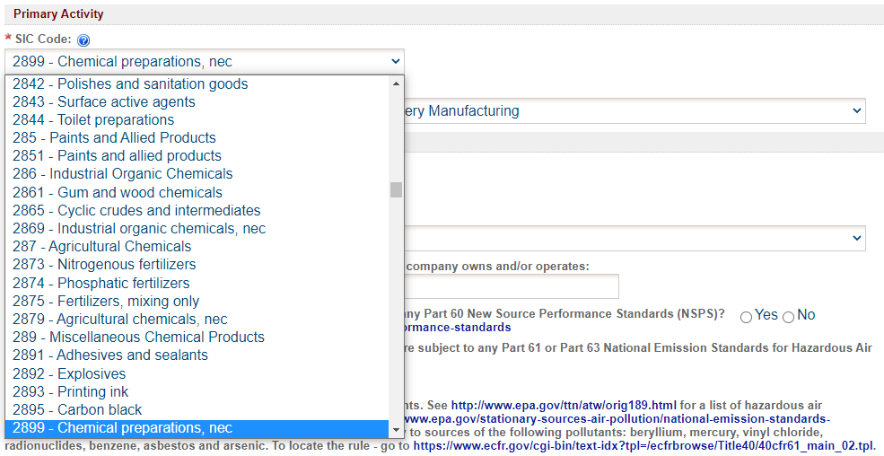

Figure 19 SIC/NAICS Code Search Example

SIC codes classify industries according to similarities in products, services, and production & delivery systems. The SIC Manual can be found at [OSHA SIC Manual](https://www.osha.gov/data/sic-manual) and a search for SIC codes can be found at [OSHA SIC Search](https://www.osha.gov/data/sic-search).

NAICS uses a six (6) digit hierarchical coding system to classify all economic activity into twenty (20) industry sectors. For more information on the conversion from SIC codes to NAICS codes go to [NAICS Association SIC to NAICS Crosswalk](https://www.naics.com/sic-naics-crosswalk-search-results/). A search for your NAICS code(s) can be found at [Census NAICS Search](https://www.census.gov/naics/).

The Primary Activity should refer to the determination of the activity in which the facility is primarily engaged. The first step in this process is to determine the facility’s activity (or activities), generally either a service or a product that “enters into commerce” (i.e. the service or product goes beyond the boundaries of the facility).

The Secondary Activity should refer to any other activities at the facility that are distinctly separate from the Primary Activity (either a service or product that “enters into commerce” in a different category than the Primary Activity) that has the lesser relative share of economic contribution (the sum of the value of production for manufacturing and value of receipts for services).

For example: a chemical manufacturing operation makes adhesives, the large majority of which are shipped off-site to customers with the remainder of the adhesives going to another activity of the facility; a plywood manufacturing operation, where all the plywood is shipped to customers. The two activities would be SIC group 28 for the chemical manufacturing operation part of the operation and SIC group 24 for the plywood manufacturing part of the operation. The primary activity would be determined by the activity (chemical manufacturing or wood product facility) that has the highest relative share of economic contribution.

**Nearby Facilities**

Next, please provide any other facilities, branches, or divisions of the company located within five (5) miles of the facility in this permit application in the text box.

**NSPS and NESHAP Subparts**

Please indicate whether you know if any emission units in this application are subject to any Part 60 New Source Performance Standards (NSPS) using the radio buttons. NSPS are Federal Regulations that apply to a wide range of sources of criteria air pollutants that typically apply to new equipment. A comprehensive list of NSPS rules are listed at the [EPA NSPS](https://www.epa.gov/stationary-sources-air-pollution/new-source-performance-standards) website. If you indicate “Yes”, a text box will appear. Please enter the name of the emission unit(s) and the applicable NSPS Subpart(s) for the equipment that is included in the application.

Please indicate whether you know if the facility or any emission units in this application are subject to any Part 61 or Part 63 National Emission Standards for Hazardous Air Pollutants (NESHAP) standard using the radio buttons. Part 63 NESHAP regulations apply to sources of hazardous air pollutants. See the [EPA Initial List of Hazardous Air Pollutants with Modifications](https://www.epa.gov/haps/initial-list-hazardous-air-pollutants-modifications) website for a list of hazardous air pollutants. To locate specific rules for source categories go to the [EPA National Emission Standards for Hazardous Air Pollutants (NESHAP)](https://www.epa.gov/stationary-sources-air-pollution/national-emission-standards-hazardous-air-pollutants-neshap-9) website. Part 61 NESHAP regulations apply to sources of the following pollutants: beryllium, mercury, vinyl chloride, radionuclides, benzene, asbestos and arsenic. To locate the rule - go to the [eCFR Part 61](https://www.ecfr.gov/current/title-40/chapter-I/subchapter-C/part-61?toc=1) website. If you indicate “Yes”, a text box will appear. Please enter the name of the emission unit(s) and the applicable NESHAP Subpart(s) for the equipment that is included in the application.

Once you have completed all the required fields, please click on “Save” and then “Next”.

## Emission Point

Next the Emission Point screen will appear. Please provide emission point information for each emission point affected by the application. This information is used by the DNR to identify the emission point (stack or vent) used for the emission unit(s) proposed in this permit application.

#### Adding a New Emission Point

To apply for a permit for new emission point, use the “Add New Emission Point” button shown in Figure 20.

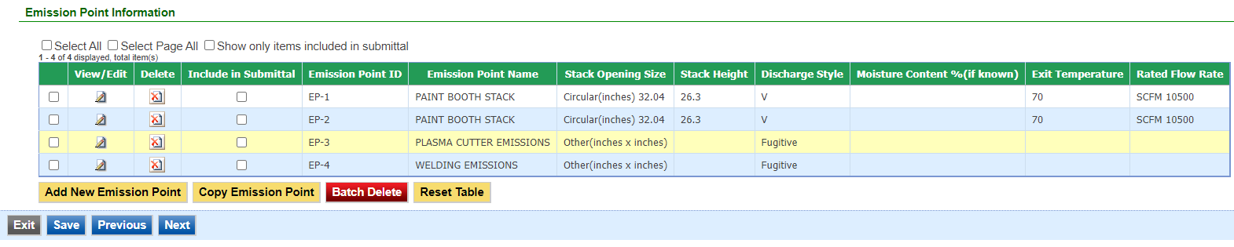

Figure 20 Emission Point Information Table Example

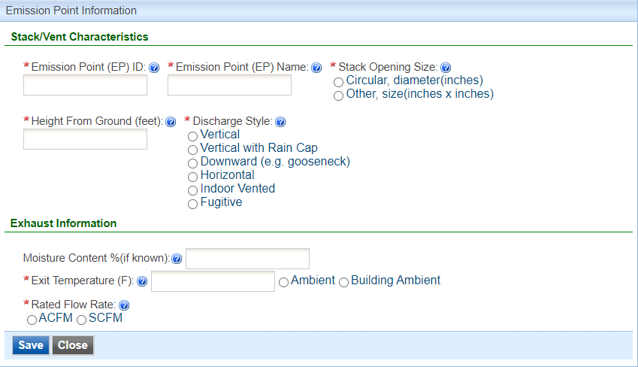

Figure 21 Emission Point Information Example

Please add the Emission Point (EP) ID, EP Name, Stack Opening Size, Height from Ground, Discharge Style, Exit Temperature, and Rated Flow Rate for the emission point. Descriptions for each field shown in Figure 21 are listed below:

**Emission Point (EP) ID:** Provide the identifier that the facility will use for this emission point,called the emission point (EP) identification (ID). It can be any combination of letters or number up to 16 characters in length.

**Emission Point (EP) Name:** Provide a unique name for the emission point (EP). It can be any combination of letters or number up to 16 characters in length.

**Stack Opening Size:** Indicate whether the stack or vent opening is circular or other for square/rectangular stacks. Provide the stack opening dimensions in inches, based on the inner diameter or opening. For “Stack-in-a Stack” discharge styles, the stack opening size is based on the outer stack.

**Height From Ground (feet):** Provide the height of the emission point from the ground to the top of the stack in feet. For “Stack-in-a Stack” discharge styles, the stack height is based on the height of the outer stack.

**Discharge Style:** Indicate the stack opening discharge style as either Vertical, Vertical with Rain Cap (i.e. does not allow for an unobstructed, upward vertical flow to the atmosphere), Downward (e.g. gooseneck), Horizontal, Indoor Vented, or Fugitive. If the air stream is vented vertically to the atmosphere and not obstructed in any manner while operating then the discharge style is Vertical. If the emission unit(s) does not vent directly to the atmosphere but rather, vents into the building, mark Indoor Vented. If the emission unit(s) does not vent through a stack and is not reasonable captured and vented to a stack, mark Fugitive. Examples of Fugitive equipment include, but are not limited to: plant roadways, storage piles, and fitting/piping losses (equipment leaks).

Examples of stacks that are equipped with rain guards that the DNR has considered Vertical (unobstructed) discharges include but are not limited to:

“Stack-in-a Stack” – This design is based on the principle that rain falls at an angle. The inner stack is surrounded by an outer stack with space between the two. Rain runs down the inside wall of the outer stack, instead of the inside wall of the inner stack.

Hexagonal Stack – This design diverts air around an internal wedge used to catch rain and air is discharged in a vertical manner. A hose is connected to the bottom of the wedge to drain collected water.

Hinged Stack – A hinged damper opens when air exhausted through the stack and closes when air is not being exhausted to prevent rain from entering the stack.

**Moisture Content %(if known):** Provide the moisture content in percent of the exhaust gas, if known. If unknown, leave blank.

**Exit Temperature (F):** Provide the temperature of the exhaust gases at the emission point in degrees in Fahrenheit (°F). You may also indicate “Ambient” (exit temperature is dependent on the temperature of the outdoor environment) or “Building Ambient” (exit temperature is dependent on the temperature of the indoor environment) as the exit temperature.

**Rated Flow Rate:** If there is a fan equipped with the emission point, give the rated capacity of the fan in actual cubic feet per minute (ACFM) or standard cubic feet per minute (SCFM). SCFM is calculated using the temperature, pressure, and ACFM of the gas flow, adjusted to EPA standard temperatures and pressure (68 °F and 14.7 psia) using the following equation:

$$SCFM=ACFM\left(\frac{T_{STP}}{T_{Actual}}\right)\left(\frac{P_{Actual}}{P_{STP}}\right)$$

Where: *Tactual* = Absolute gas temperature at actual conditions (°R)

*TSTP* = Absolute gas temperature at standard conditions (°R), 528 °R

*PActual* = Absolute gas pressure at actual conditions (psia)

*PSTP* = Absolute gas pressure at standard conditions (psia), 14.7 psia

If the pressure is unknown, the DNR will assume that the *PActual* and *PSTP* are equal to simplify the equation, as shown below, with temperature conversions included for reference:

$$SCFM=ACFM\left(\frac{(68°F+460)°R }{(T_{Actual}+460)°R}\right)$$

Where: *Tactual* = Absolute gas temperature at actual conditions (°F)

When you are finished with entering information for the emission point, please click “save” to add the emission point to the list, then click “save” at the bottom of the screen to save the emission point(s) to the application.

It is recommended that you save after entering in each emission point to prevent losing your progress. If you do not click “save” before loading into another page, you will lose your current progress entering information.

#### Modifying an Existing Emission Point

To apply to modify a permit for existing emission point that is in the system, find the Emission Point ID in the table. If the emission point is not in the table, use “Add New Emission Point” and follow the instructions above.

When modifying an existing emission point, check the “Include in Submittal” checkbox in the emission point table. This will highlight the emission point in red to indicate that it is included in the application, as shown below. Then, don’t forget to click the save button on the main Emission Point screen. A green check mark will appear to confirm that the data is saved. To modify the emission point information, click the “pencil and paper” icon under “View/Edit” (see Figure 22), then follow the instructions above for entering emission point information.

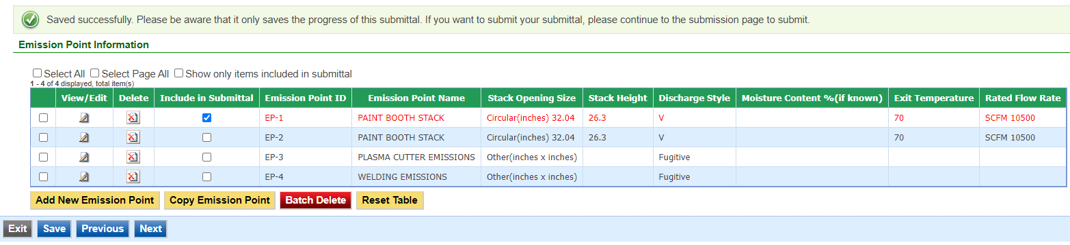

Figure 22 Emission Point Modification Example

#### Deleting an Emission Point

If you need to delete an emission point, use the “red x on paper” icon to remove the emission point from the table. A pop-up warning will appear to confirm that you would like to delete the emission point.

Do not delete emission points from this table that exist at the facility but are not a part of the application, as this will remove them from your facility inventory.

#### Copying an Emission Point

Copying an emission point can be useful to save time when entering in emission point information for similar or identical stacks. To copy an emission point, select the emission point you would like to copy in the first column of the table using the checkbox and click the “Copy Emission Point” button as shown in Figure 23.

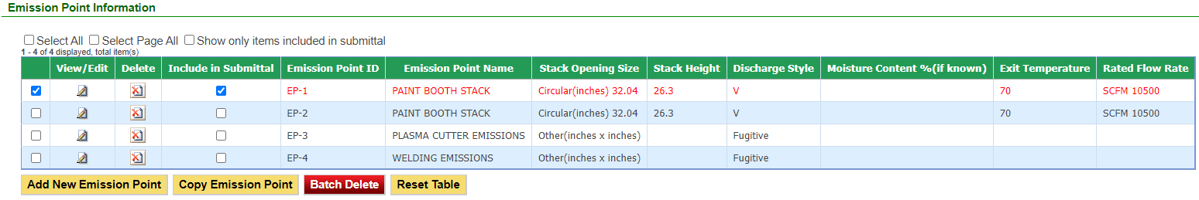

Figure 23 Copying an Emission Point Example

A new screen will pop up to enter in a new emission point ID and emission point name, as shown below in Figure 24. Use the instructions above in the New Emission Points section for the ID and name.

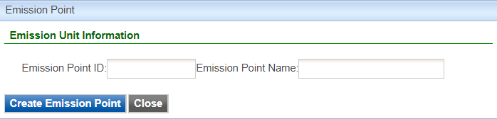

Figure 24 Copying an Emission Point Example

When you have finished entering the information for the copy of the emission point, click “Create Emission Point”. This will create a copy of the emission point in the emission point table, but will not save it to the table. Click on the “Include in Submittal” checkbox and then click “Save” at the bottom of the screen to save it to the emission point table. If you need to modify any aspect of the newly created emission point, use the “pencil and paper” icon to edit the emission point.

#### Other Emission Point Table Functionality

At the top of the emission point table, there will be three checkboxes by default: “Select All”, “Select Page All”, and “Show only items included in submittal”.

Clicking on “Select All” will check the checkbox in the first column of the table for **all** emission points, even if they are on a different page. Clicking on “Select Page All” will check the checkbox for all emission points on the current page (if there are multiple pages). These two functions can be used with the “Batch Delete” button at the bottom of the page to simplify deleting large amounts of emission points.

Clicking on “Show only items included in submittal” will display only the emission points that have been marked as “Include in Submittal” within the emission point table. This can be useful if there are multiple pages of emission points for a facility, where only one or two emission points are being modified.

Clicking on “Reset Table” will reset the emission point table to be based on the information originally pulled from the State & Local Emissions Inventory System (SLEIS).

It is not recommended to use this function, since there may have been multiple modifications made to the specific emission points since the information was originally pulled from SLEIS.

#### Finishing Up

The emission point table should include all emission points affected by the application, even if the emission point characteristics are not specifically being changed.

For example, if an emission unit is being added to a facility and it is installed to be vented through an existing emission point, the emission point information for that equipment should be included even if the stack characteristics are unchanged.

Once you have finished entering the information, click “Save” and then “Next”.

## Control Equipment

Next the Control Equipment screen will appear. Please provide control equipment information for each emission point affected by the application. This information is used by the DNR to identify the control equipment used for the emission unit(s) proposed in this permit application.

#### Adding a New Control Equipment Device

To add a new piece of control equipment, use the “Add New Control Equipment” button as shown in Figure 25.

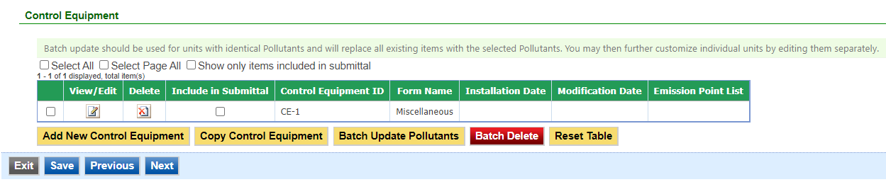

Figure 25 Control Equipment Table Example

A Control Equipment screen will appear to enter the information for the control equipment (See Figure 26).

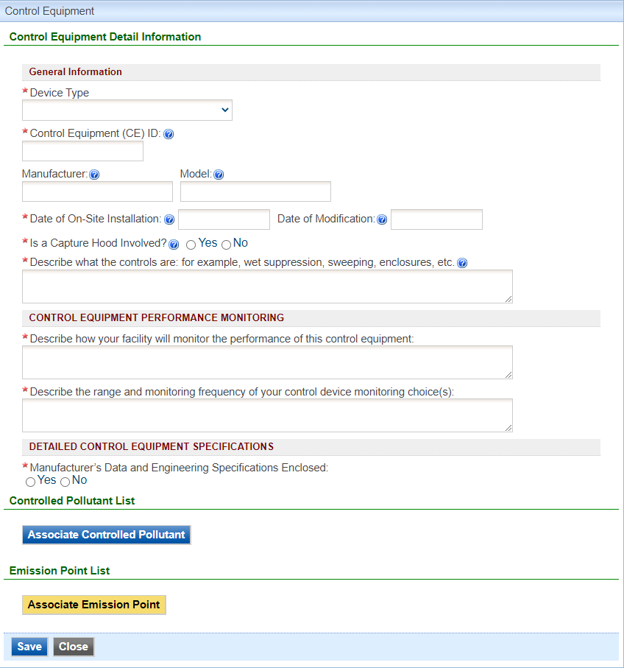

Figure 26 Control Equipment Data Entry Example

Please add the required information (and non-required information, if relevant to the operation of the control equipment device) for the control equipment device. Descriptions for each field shown in Figure 24 are listed below:

**Device Type:** Select the type of control equipment device from the drop-down menu. The options are Catalytic & Non-Catalytic Reduction, Catalytic Oxidation, Cyclones, Dry Filter, Fabric Filters, Mist Eliminator, Thermal Oxidation, or Wet or Dry Scrubber. If the specific device type is not listed, select “Miscellaneous”. Brief descriptions of each type of control equipment device are listed below for reference. The links will lead you to the applicable section for device-type specific instructions.

Catalytic & Non-Catalytic Reduction: Catalytic & Non-Catalytic Reduction control devices are applied to combustion devices to control nitrogen oxides (NOX) emissions.

In selective non-catalytic reduction systems, the ammonia (NH3) or urea is injected into a very hot gas zone where thermal reactions leading to the chemical reduction of nitrogen oxides can occur.

In selective catalytic reduction, beds containing ammonia or urea reduce nitrogen oxides to molecular nitrogen and water. The catalysts are usually composed of tungsten and vanadium deposited through a substrate that is extruded into a honeycomb arrangement.

Catalytic Oxidation: Catalytic oxidizers, also known as catalytic incinerators, are oxidation systems (similar to thermal oxidizers) that control volatile organic compounds (VOCs) and volatile hazardous air pollutant (HAP) emissions. Catalytic oxidizers use a catalyst to promote the oxidation of VOCs to CO2 and water (i.e. increase the kinetic rate). The catalyst therefore allows oxidation to occur at lower temperatures than for thermal oxidation; catalytic oxidizers generally operate between 650°F and 1000°F.

Cyclones: Cyclones use centrifugal and inertial forces to separate particulate matter (PM) from the contaminated gas stream as it spirals through the cyclone.

Dry Filter:Dry filter refers to the dry filters used on spray paint booths used to collect particulate matter (PM) on the surface of the filter material. If other control equipment is used, please select the appropriate control equipment from the drop-down menu.

Fabric Filters: Fabric filters refer to any type of control device that collects particulate matter on the surface of filter bags by inertial impaction, interception, Brownian diffusion, and sieving on already collected particles that have formed a dust layer on the bags.

Mist Eliminator: Mist eliminators refer to the particular use in cooling tower operations, which are used primarily to remove entrained droplets and therefore control particulate matter (PM) emissions from the cooling tower exhaust.

Thermal Oxidation: Thermal oxidizers, or thermal incinerators, are combustion devices that control volatile organic compounds (VOCs), carbon monoxide (CO), and volatile hazardous air pollutant (HAP) emissions by combusting them to carbon dioxide (CO2) and water.

Wet or Dry Scrubber: Wet scrubbers are devices which use a liquid for the removal of emissions of both particulate matter (PM) and gaseous pollutants. These can include venturi scrubbers, impingement plate scrubbers, spray tower scrubbers, and packed bed scrubbers.

Dry scrubbers are devices typically control sulfur dioxide (SO2) emissions using absorption or adsorption principles. These can include spray atomizer dry scrubbers, spray dryer type dry scrubbers, or dry sorbent injection systems.

Miscellaneous: Please select this type if the control device does not fit under any of the definitions above. Provide the type of control equipment used from the dropdown list (See Figure 27). If the specific type of control equipment is not listed, use “Other”.

A table listing all of the "Miscellaneous" control equipment types. The table lists the following types:
Activated Carbon Injection, Afterburner, Baghouse, Biofilter, Catalytic Reduction, Condenser, Cyclone, Dry, Dry Sorbent Injection (DSI, other than ACI), Dust Suppression, Electrostatic Precipitator - Dry (DESP), Enclosed Flame, External Floating Roof Tank, Flare, Flue Gas Recirculation, Internal Floating Roof, Leak Detection and Repair (LDAR) Program, Low NOx Burner (LNB), Multiclone, Nitrogen Blanket, Non-Catalytic Reduction, Other Control Device, Overfire Air, Packed Bed, Recuperative, Regenerative, Screen, Spray Chamber, Steam Injection, Submerged Filling, Sulfuric Acid Plant, Ultra Low NOx Burners (ULNB), Vapor Recovery Unit, Venturi, Water Curtain, and Water Injection.

Figure 27 Miscellaneous Control Equipment Types

The descriptions for each field are broken into separate sections for each control equipment type. Due to the similarities between control equipment forms, please refer to the “Miscellaneous” Control Equipment type for an explanation of the standard fields for a control equipment form. Fields that are specific to each control equipment type are explained in the labeled sections below.

You may skip to the applicable section for instructions for each control equipment type using the links for each control equipment type listed above.

#### Miscellaneous/General Control Equipment Form Information

**Control Equipment (CE) ID:** Called the control equipment (CE) identification (ID). It can be any combination of letters or numbers up to 16 characters in length. The ID should match the ID for this control equipment used on previous construction permit applications and within this application. If also submitting an operating permit application, the ID used in this application should be consistent with those used in the operating permit application.

**Manufacturer:** Provide the manufacturer of the control equipment (if known).

**Model:** Provide the model number of the control equipment (if known). If custom, enter “Custom”.

**Date of On-Site Installation:** Provide the date when on-site installation of the control equipment began or will begin, including the month and year. If you don’t know the month, use January 1st of the known year.

**Date of Modification:** Provide the month and year of the last modification. In the case of a proposed modification, provide the best estimate of the modification date. For the purpose of this form, ***Modification*** means any physical change, or change in method of operation of any existing equipment or control equipment. If you don’t know the month, use January 1st of the known year.

**Capture Hood:** Indicate whether there is a capture hood associated with the emission unit and control device. A Capture Hood catches air pollution at the emission unit and directs to the control device. It is used when the control equipment is not in a closed system with the emission unit.

**Capture Hood Efficiency:** If there is a capture hood, list the capture efficiency, if known. The capture hood efficiency can be obtained from the hood manufacturer or vendor.

**Type of Control Equipment:** Describe the type of control equipment. This name will be used to describe the control equipment in the construction permit.

**Control Equipment Performance Monitoring:** Describe how your facility will monitor the performance of this control equipment using the checkboxes for the applicable monitoring technique. Additional monitoring may be required by the DNR to ensure compliance with requested permit limits. Examples of control equipment monitoring include monitoring pressure drop for an oxidation catalyst, resistivity and pressure drop for an ESP, visual inspection for a floating roof, or annual tuning or maintenance for a low NOx burner.

Describe the range (e.g., pressure drop, temperature differential, etc.) and the frequency of each monitoring choice selected from above. The range should provide for the normal operating range of the equipment and can be obtained from the manufacturer and vendor. The range could also be determined from stack testing. The applicant should provide an estimate of the frequency of parameter monitoring they feel is reasonable. Frequency can be as often as continuously or can be as little as annually depending on the type of equipment, the monitoring parameter chosen, and the importance of the control equipment to meet the emissions limits requested in the permit.

**Manufacturer’s Data and Engineering Specifications:** Indicate whether supporting documentation, such as manufacturer’s data or engineering specifications, is attached. The manufacturer’s data should provide a general description of the control equipment and specific design specifications that would answer the remaining questions in this section of the form. If yes, attach as a separate sheet labeled “Form CE6-10A”. If supporting documentation is not attached, the department may request specific design and operational specifications for the equipment.

#### Catalytic & Non-Catalytic Reduction

**Type of Control Equipment:** Select the type of control equipment using the radio buttons for either Catalytic Reduction or Non-Catalytic Reduction. Descriptions of each type are listed above in the Device Type description. You will then be asked to provide a description of the control equipment, and the options for Control Equipment Performance Monitoring will change based on the option selected.

**Control Equipment Performance Monitoring:** Examples of control equipment monitoring are listed for each type of control equipment, listed below:

*Catalytic Reduction*:   
Catalyst Material Coupon or Sample Testing, Catalyst Life Time, Operating Temperature Range, Pressure Drop, Ammonia (or Urea) Injection Rate, Outlet Ammonia Concentration, Predictive Emissions Monitoring System (PEMS), Continuous Emissions Monitoring System (CEMS), or Other.

*Non-Catalytic Reduction*:   
Operating Temperature Range, Ammonia (or Urea) Injection Rate, Outlet Ammonia Concentration, Predictive Emissions Monitoring System (PEMS), Continuous Emissions Monitoring System (CEMS), or Other.

**Catalyst Material:** If the control equipment has a catalyst, provide the type of material.

**Catalyst Life Time:** If the control equipment has a catalyst, provide the catalyst life time (i.e. how long the catalyst needs to be replaced or regenerated).

**Number of Catalyst Beds:** If the control equipment has a catalyst, provide the number of beds.

**Total Catalyst Bed Volume:** If the control equipment has a catalyst, provide the total volume of the catalyst beds.

**Residence Time:** Provide the residence time of the control equipment. This is not a value easily calculated by the applicant and should be provided by the vendor.

**Operating Temperature Range(°F):** Provide the temperature range in which the control equipment will operate in degrees Fahrenheit.

**Pressure Drop Range:** If the control equipment has a catalyst bed, provide the operating pressure drop range across the catalyst bed(s).

**Additive Injection Rate:** Provide the amount of additive that will be injected into the control system. In addition, check the appropriate box for the type of additive to be used.

**Maximum Ammonia Slip(ppm):** Ammonia slip refers to the amount of unreacted ammonia. Provide the maximum amount of ammonia to be emitted from the emission point.

#### Catalytic Oxidation

**Type of Control Equipment:** Describe the type of catalytic oxidation equipment. This name will be used to describe the control equipment in the construction permit.

**Control Equipment Performance Monitoring:** Examples of control equipment monitoring are listed below:

Catalyst Material Coupon or Sample Testing, Catalyst Life Time, Catalyst Inlet Temperature, Residence Time, Oxidizer Minimum Operating Temperature, Predictive Emissions Monitoring System (PEMS), Continuous Emissions Monitoring System (CEMS), or Other.

**Catalyst Material:** Provide the material used as a catalyst.

**Catalyst Life Time:** Provide the catalyst life time (i.e. how long before the catalyst needs to be replaced or regenerated).

**Residence Time (seconds):** Provide the residence time of the oxidizer in seconds. This is calculated by dividing the internal volume of the oxidizer by the air flow through the oxidizer.

**Oxidizer Minimum Operating Temperature (°F):** Provide the minimum operating temperature of the oxidizer in degrees Fahrenheit.

**Catalyst Inlet Temperature (°F):** Provide the temperature of the air stream at the inlet to the catalyst bed in degrees Fahrenheit.

#### Cyclones

**Type of Control Equipment:** Describe the type of cyclone. This name will be used to describe the control equipment in the construction permit.

**Control Equipment Performance Monitoring:** Examples of control equipment monitoring are listed below:

Pressure Drop, Control Equipment Inspections and Maintenance, Visible Emissions Observation, or Other.

**Inlet Velocity (ft/min):** Provide the inlet duct velocity, as designed in feet per minute.

**Cyclone Body Length (in):** Provide the cyclone body length in inches.

**Internal Diameter (in):** Provide the internal diameter of the conical section of the cyclone, as designed in inches.

**Pressure Drop Range (in H2O):** Provide the expected pressure drop (in inches of H2O).

#### Dry Filter

**Filter Dimensions (length x width):** Provide the length and width of the filter(s) in feet.

#### Fabric Filters

**Type of Control Equipment:** Describe the type of fabric filters. This name will be used to describe the control equipment in the construction permit.

**Control Equipment Performance Monitoring:** Examples of control equipment monitoring are listed below:

Pressure Drop, Outlet Pollutant Concentration, Bag Leak Detection System, Control Equipment Inspections and Maintenance, Visible Emissions Observation, Cleaning Operation Frequency, Parametric Pollution Concentration, or Other.

**Pressure Drop Range (in H2O):** Provide the expected pressure drop range (in inches of H2O).

**Filter Media Material:** Provide the type of filter media material.

**Total Filter Face Area of Control Device (ft2):** Provide the total filter area of the control device in ft2.

**Bag Cleaning Method:** For baghouses, indicate the method that is used to clean the filter media, if applicable.

#### Mist Eliminator

**Mist Eliminator Efficiency (% transmitted):** Provide the mist eliminator efficiency of the equipment. Mist eliminator efficiency is rated in percent of mist transmitted. The mist eliminator efficiency can be obtained from the cooling tower manufacturer.

#### Thermal Oxidation

**Type of Control Equipment:** Describe the type of thermal oxidizer. This name will be used to describe the control equipment in the construction permit.

**Control Equipment Performance Monitoring:** Examples of control equipment monitoring are listed below:

Combustion Chamber Temperature Range, Flare Pilot Flame, Oxidizer Minimum Operating Temperature, Residence Time, Predictive Emissions Monitoring System (PEMS), Continuous Emissions Monitoring System (CEMS), or Other.

**Oxidizer Minimum Operating Temperature (°F):** Provide the minimum operating temperature of the oxidizer in degrees Fahrenheit.

**Residence Time (seconds):** Provide the residence time of the oxidizer in seconds. This is calculated by dividing the internal volume of the oxidizer by the air flow through the oxidizer.

#### Wet or Dry Scrubber

**Type of Control Equipment:** Describe the type of wet or dry scrubber. Descriptions of each type are listed above in the Device Type description. This name will be used to describe the control equipment in the construction permit.

**Control Equipment Performance Monitoring:** Examples of control equipment monitoring are listed below:

Total Liquor Flow Rate, Recycled Liquor Flow Rate, Inlet Liquor Temperature, Pressure Drop, Control Equipment Inspections and Maintenance, Visible Emissions Observation, or Other.

**Type of Additive Used:** If any additive is used in the scrubber liquor to improve pollutant control, provide the type(s) of additive here. Include manufacturer’s documentation if available as a separate attachment labeled “CE3-12A”.

**Additive Feed Rate:** If any additive is used, provide the feed rate(s) in either gallons per minute for liquid additives or pounds per minute for solid additives. Please indicate whether the feed rate provided is in gallons or pounds per minute.

**Total Liquor Flow Rate:** Provide the total liquor (scrubbing liquid) flow rate across the scrubber, in a minimum gallons per minute. If there is a recycle line for the scrubber, the total flow rate can be calculated by adding the recycle flow to the makeup flow.

**Recycle Liquor Flow Rate:** If there is a recycle line in the scrubber, provide the recycled liquor (scrubbing liquid) flow rate, in a minimum gallons per minute.

**Maximum Inlet Liquor Temperature:** Provide the maximum inlet liquor (scrubbing liquid) temperature in degrees Fahrenheit.

**Normal Liquor pH:** Provide the normal pH operating range of the liquor (scrubbing liquid).

**Pressure Drop Range (in H2O):** Provide the expected pressure drop range (in inches of H2O).

**Design Data for the Applicable Type of Scrubber:** In addition to the specific questions asked concerning flow rate, pH, and pressure drop the applicant must also provide the design data used for the specific type of scrubber. This can involve throat velocity for a venture scrubber, type of packed bed material and size of packing material for a packed bed scrubber, air-to-volume ratio, etc. Attach this information as a separate sheet labeled “CE3-15A”.

#### Associating Controlled Pollutants

Next, you must associate controlled pollutants to the newly added control equipment by clicking on “Associate Controlled Pollutant”. The following screen will appear as shown in Figure 28 below:

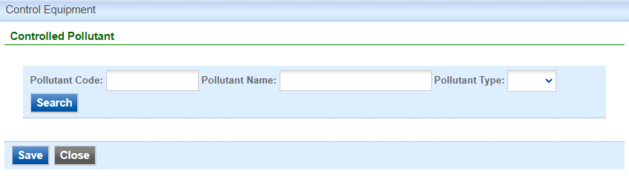

Figure 28 Associate Controlled Equipment Screen

To associate a controlled pollutant, you may search for a specific pollutant using the pollutant code, pollutant name, or pollutant type fields. If you leave each field blank and click on “Search”, the system will provide a complete list of pollutants available to select from in the system.

**Pollutant Codes:** Pollutant codes are abbreviated codes that are used to quickly search for a specific pollutant. The main criteria air pollutants (CAP) codes are listed below for quick reference in Figure 29:

|  |  |
| --- | --- |
| **Pollutant Code** | **Pollutant Name** |
| PM25-PRI | PM2.5 |
| PM10-PRI | PM10 |
| PM-PRI | Total PM |
| SO2 | Sulfur Dioxide |
| NOX | Nitrogen Oxides |
| VOC | Volatile Organic Compounds |
| CO | Carbon Monoxide |
| 7439921 | Lead |
| OZ | Ozone |
| NH3 | Ammonia |
| NMOC | NMOC |

Figure 29 Criteria Air Pollutant Codes

For Hazardous Air Pollutants (HAP), the pollutant code will be the CAS number associated with the pollutant without any hyphens (e.g., acetaldehyde would be 75070). For Total HAP, the pollutant code is THAP; for Single HAP, the pollutant code is SHAP.

Pollutant codes for the pollutant type Other (OTH) are listed below for quick reference in Figure 30:

|  |  |
| --- | --- |
| **Pollutant Code** | **Pollutant Name** |
| FL | Fluoride Compounds |
| 110009 | Furans |
| 7783064 | Hydrogen Sulfide |
| LNDFLGAS | Landfill Gas |
| REDCDSCMPS | Reduced Sulfur Compounds |
| H2SO4 MIST | Sulfuric Acid Mists |
| 540885 | Tert-butyl Acetate |
| Opacity | Opacity |
| Hg | Hg |
| HCI | HCL |
| Diluent O2 | Diluent O2 |
| Diluent CO2 | Diluent CO2 |
| flow | flow |

Figure 30 “Other” Pollutant Codes

**Pollutant Name:** The pollutant name field will search based on if the search term is contained in any of the results (e.g., a search for “PM” results in “PM2.5”, “PM10”, and “Total PM”).

**Pollutant Type:** The pollutant type separates the results based on the type. “CAP” refers to Criteria Air Pollutant, “HAP” refers to Hazardous Air Pollutant, and “OTH” refers to Other.

**Control Efficiency:** For each pollutant controlled, indicate the overall efficiency of the control device, as designed.

Once you have finished adding a controlled pollutant with a control efficiency, select “Save” to add this information to the control equipment form.

Repeat this process for each controlled pollutant. You may enter multiple controlled pollutants at a time if they have the same control efficiency. For example: if you select PM2.5, PM10, and Total PM, and apply a 95% control efficiency for these pollutants, the 95% control efficiency will be applied to each pollutant without the need to add them separately.

#### Associating Emission Points

To complete the control equipment form, please associate the control equipment with the appropriate emission point by clicking on “Associate Emission Point”. The previously completed emission point table will appear, as shown below in Figure 31:

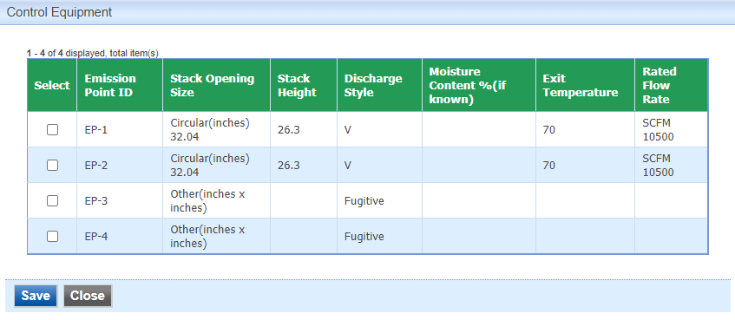

Figure 31 Associate Emission Point Screen

Please select the emission point(s) that the control equipment will vent to, and then select “Save” to add this information to the control equipment form. Please click “save” at the bottom of the screen to save the control equipment to the application.

It is recommended that you save after entering in each control equipment to prevent losing your progress. If you do not click “save” before loading into another page, you will lose your current progress entering information.

#### Modifying Existing Control Equipment

To modify existing control equipment that is in the system, find the Control Equipment ID in the table. If the control equipment is not in the table, use “Add New Control Equipment” and follow the instructions above.

When modifying existing control equipment, check the “Include in Submittal” checkbox in the control equipment table (See Figure 32). This will highlight the control equipment in red to indicate that it is included in the application, as shown below. Then, don’t forget to click the save button on the main Control Equipment screen. A green check mark will appear to confirm that the data is saved. To modify the control equipment information, click the “pencil and paper” icon under “View/Edit”, then follow the instructions above for entering control equipment information.

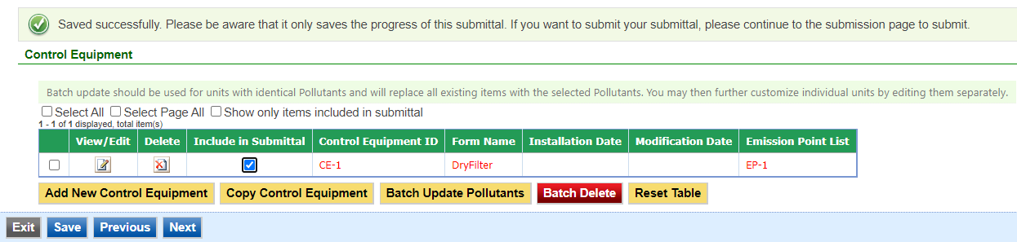

Figure 32 Control Equipment Modification Example

#### Deleting Control Equipment

If you need to delete control equipment, use the “red x on paper” icon to remove the equipment from the table. A pop-up warning will appear to confirm that you would like to delete the control equipment.

Do not delete control equipment from this table that exist at the facility but are not a part of the application, as this will remove them from your facility inventory.

#### Copying Control Equipment

Copying control equipment can be useful to save time when entering in control equipment information for similar or identical devices. The copy control equipment function should only be used for equipment with identical installation dates. To copy a control equipment entry, select the control equipment you would like to copy in the first column of the table using the checkbox and click the “Copy Control Equipment” button (See Figure 33).

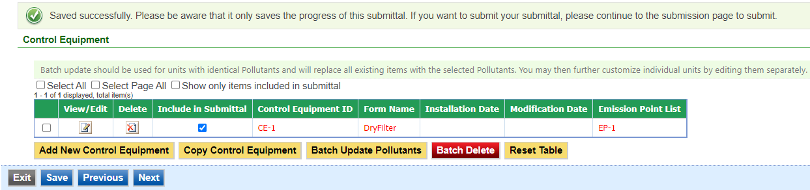

Figure 33 Copying a Control Equipment Entry Example

A new screen will pop up to enter in a new control equipment ID, as shown below in Figure 34. Use the instructions above in the Adding a New Control Equipment Device section for the ID.

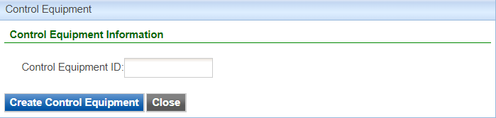

Figure 34 Copying a Control Equipment Entry Example

When you have finished entering the information for the copy of the control equipment, click “Create Control Equipment”. This will create a copy of the control equipment in the control equipment table, but will not save it to the table. Click on the “Include in Submittal” checkbox and then click “Save” at the bottom of the screen to save it to the control equipment table. If you need to modify any aspect of the newly created control equipment entry, use the “pencil and paper” icon to edit the control equipment.

#### Other Control Equipment Functionality

At the top of the control equipment table, there will be three checkboxes by default: “Select All”, “Select Page All”, and “Show only items included in submittal”.

Clicking on “Select All” will check the checkbox in the first column of the table for **all** control equipment entries, even if they are on a different page. Clicking on “Select Page All” will check the checkbox for all control equipment on the current page (if there are multiple pages). These two functions can be used with the “Batch Delete” button at the bottom of the page to simplify deleting multiple control equipment. These functions can also be used with the “Batch Update Pollutants” button at the bottom of the page.

Clicking on the “Batch Update Pollutants” button will prompt you to input controlled pollutants for multiple control equipment at a single time. Batch update should be used for units with identical pollutants and will replace all existing items with the selected pollutants. Please refer to the Associating Controlled Pollutants section for more details on adding controlled pollutants. You may then further customize individual units by editing them separately.

Clicking on “Show only items included in submittal” will display only the control equipment that have been marked as “Include in Submittal” within the control equipment table. This can be useful if there are multiple pages of control equipment for a facility, where only one or two control equipment devices are being modified.

Clicking on “Reset Table” will reset the control equipment table to be based on the information originally pulled from the State & Local Emissions Inventory System (SLEIS).

It is not recommended to use this function, since there may have been multiple modifications made to the specific control equipment since the information was originally pulled from SLEIS.

#### Finishing Up

The control equipment table should include all control equipment affected by the application, even if the control equipment characteristics are not specifically being changed.

For example, if an emission unit is being added to a facility and it is installed to be vented through an existing control equipment, the control equipment information for that equipment should be included even if the characteristics are unchanged.

Once you have finished entering the information, click “Save” and then “Next”.

## Emission Unit

Next the Emission Unit screen will appear. Please provide emission unit information for each emission point affected by the application. This information is used by the DNR to identify the emission unit(s) venting through the emission point(s) proposed in this permit application.

#### New Emission Units

To add a new emission unit, use the “Add New Emission Unit” button (See Figure 35).

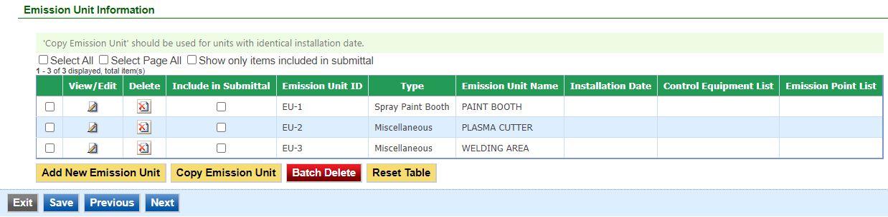

Figure 35 Emission Unit Table Example

An Emission Unit screen will appear to enter the information for the emission unit as shown in Figure 36.

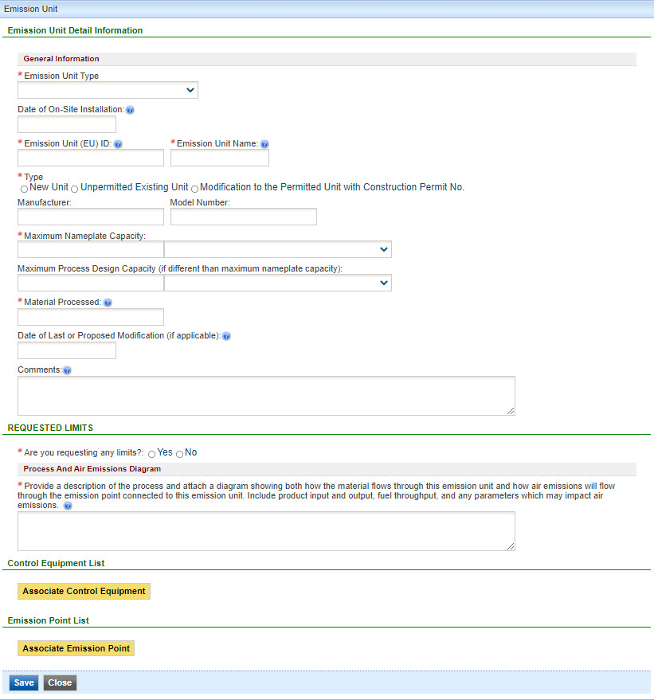

Figure 36 Emission Unit Data Entry Example

Please add the required information (and non-required information, if relevant to the operation of the emission unit) for the emission unit. Descriptions for each field are listed below:

**Emission Unit Type:** Select the type of emission unit from the drop-down menu. The options are Cooling Tower, Boiler, Internal Combustion Engines, Nonmetallic Mineral Processing Plant, and Spray Paint Booth. If the specific device type is not listed, select “Miscellaneous”. Brief descriptions of each type of emission unit are listed below for reference. The links will lead you to the applicable section for device-type specific instructions.

Cooling Tower: A heat rejection device that rejects waste heat to the atmosphere through the cooling of a coolant stream, usually a water stream to a lower temperature.

Boiler: A closed vessel or arrangement of vessels and tubes, together with a furnace or other heat source, in which steam or other vapor is generated from water to drive turbines or engines, supply heat, process certain materials, etc.

Internal Combustion Engine: An engine that generates motive power by the burning of gasoline, oil, or other fuel with air inside the engine, the hot gases produced being used to drive a piston or do other work as they expand.

Nonmetallic Mineral Processing Plant: As defined at 40 CFR §60.671, any combination of equipment that is used to crush or grind any nonmetallic mineral wherever located, including lime plants, power plants, steel mills, asphalt concrete plants, portland cement plants, or any other facility processing nonmetallic minerals, except as provided in § 60.670 (b) and (c).

* This form is intended for equipment at nonmetallic mineral processing plants, as defined in 40 CFR §60.671, that generate fugitive emissions only. Forms EU, EP and CE should be used for each emission unit that exhausts through a stack or vent from the same plant, such as an engine or storage silo with a bin vent or baghouse.

Spray Paint Booth: An enclosed or semi enclosed area used for the spray painting of fabricated items. This form needs to be completed for each spray paint booth in the application.

Miscellaneous: Please select this type if the emission unit does not fit under any of the definitions above. Provide the subtype of emission unit from the dropdown list (See Figure 37). If the specific type of emission unit is not listed, use the applicable “Other” categories.

|  |  |  |  |
| --- | --- | --- | --- |
| Air Gas Furnace | Evaporator | Open Tank or Vat | Roof vents/Building vents |
| Calciner | Finish Mill | Other combustion | Saw |
| Chemical Reactor | Flare | Other evaporative sources | Screen |
| Chipper/Flaker/Hammermill | Furnace | Other fugitive | Silo |
| Condensate Stripper | Gasoline Loading Rack or Arm | Other process equipment | Sludge Storage Lagoons/Drying Beds |
| Conveyor | Grinder | Oxidation Unit | Storage bin |
| Crusher | Incinerator | Primary Condenser | Storage Tank |
| Curing Oven | Indirect-fired Dryer | Primary Tube Dryer | Thin Film Evaporator |
| Degreaser | Kiln | Printing Line | Transfer Point |
| Direct-fired Dryer | Miscellaneous Coating Operation | Process Equipment and Process Area Drains | Transfer System |
| Distillation Column/Stripper | Mixer or Blender | Process Equipment Fugitive Leaks | Turbine |
| Dryer, unknown if direct or indirect. | Non-TSDF Treatment, Storage, Disposal System | Process Heater | Unclassified |
| Duct Burner | Open Air Fugitive Source | Process Vent | Vapor Incinerator |
| Engine Test Cell | Open Storage Pile | Regenerative Furnace |  |

Figure 37 Miscellaneous Emission Unit Types

The descriptions for each field are broken into separate sections for each emission unit type. Due to the similarities between emission unit forms, please refer to the “Miscellaneous” Emission Unit type for an explanation of the standard fields for an emission unit form. Fields that are specific to each emission unit type are explained in the labeled sections below.

You may skip to the applicable section for instructions for each emission unit type using the links for each emission unit type listed above.

#### Miscellaneous/General Emission Unit Form Information

**Date of On-Site Installation:** Provide the date when on-site installation of the emission unit began or will begin, including the month and year. If you don’t know the month, use January 1st of the known year.

**Emission Unit (EU) ID:** Called the emissions unit (EU) identification (ID). Each source in the application must have its own identifier. It can be any combination of letters or numbers with maximum of 16 characters. The ID should match the ID for this equipment used on other construction permit applications and within this application. If also submitting an operating permit application, the ID used in this application should be consistent with those used in the operating permit application.

**Emission Unit Name:** Provide the name of the emission unit, such as Printer #4, Curing Oven #3, Storage Tank #2, etc.

**Type:** Indicate “New Unit” for an emission unit intended to be installed at the site, or “unpermitted existing unit” for an emission unit already installed at the site. If the emission unit already has a construction permit and is being modified, indicate so and provide the current construction permit number.

**Manufacturer:** Provide the name of the manufacturer of the emission unit (if known). If custom, enter “Custom”.

**Model Number:** Provide the model number of the emission unit (if known). If custom, enter “Custom”.

**Maximum Nameplate Capacity:** Provide the maximum nameplate capacity of the emission unit. Capacity should be based on a rated nameplate or capacity in the manufacturer’s literature. For example, a bake oven capacity may be rated in terms of heat input of natural gas (MMBtu/hr); an assembly line capacity may be rated in terms of parts produced per hour. If it is a batch operation, list the individual batch capacity.

Provide the units for the maximum nameplate capacity from the list in the drop-down menu, which are copied in Figure 38 below for reference. If the units are not listed in this table, select “OTHER” and specify the units in the “Comments” section.

|  |  |  |
| --- | --- | --- |
| ACRE | FEET PER HOUR | MILLION POUNDS PER HOUR |
| AMPERE-HOURS | FEET PER MINUTE | MILLION STANDARD CUBIC FEET PER HOUR |
| BARRELS | GALLONS | Other |
| BARRELS PER DAY | GALLONS PER DAY | POUNDS |
| BARRELS PER HOUR | GALLONS PER HOUR | POUNDS PER DAY |
| BARRELS PER YEAR | GALLONS PER MINUTE | POUNDS PER HOUR |
| BOARD FEET PER DAY | GALLONS/YEAR | POUNDS PER MINUTE |
| BOARD FEET PER HOUR | HORSEPOWER | POUNDS PER YEAR |
| BTU PER HOUR | INCHES/HR | SQUARE FEET |
| BUSHELS PER HOUR | KILOWATTS | STANDARD CUBIC FEET PER HOUR |
| CUBIC FEET PER DAY | MEGAGRAMS | STANDARD CUBIC FEET PER MINUTE |
| CUBIC FEET PER HOUR | MEGAWATTS | TONS |
| CUBIC FEET PER MINUTE | MILES PER YEAR | TONS PER DAY |
| CUBIC FEET PER YEAR | MILLION BTU PER HOUR | TONS PER HOUR |
| CUBIC METERS | MILLION BTU PER YEAR | TONS PER YEAR |
| CUBIC YARDS PER HOUR | MILLION CUBIC FEET PER HOUR | UNIT/HR |
| DRY STANDARD CUBIC FEET PER HOUR | MILLION CUBIC FEET PER YEAR | VMT/HR |
| DRY STANDARD CUBIC FEET PER MINUTE | MILLION GALLONS PER YEAR |  |

Figure 38 Capacity Units of Measure

**Maximum Process Design Capacity:** Provide the maximum process design capacity of the emission unit, if different than maximum nameplate capacity. For example, a process might have a long-term capacity; or, if there are multiple components or operational considerations, the maximum capacity the process can achieve may be lower than the maximum nameplate capacity. If the capacity is limited due to a bottleneck, please indicate it in the “Comments” section.

Provide the units for the maximum nameplate capacity from the list in the drop-down menu, which are copied in table below for reference. If the units are not listed in this table, select “OTHER” and specify the units in the “Comments” section.

**Material Processed:** Provide the type of raw material processed, finished product(s), and any types of fuels used in the emission unit.

**Date of Last or Proposed Modification:** Providethe month and year of the last modification. In the case of a proposed modification, provide the best estimate of the modification date. For the purpose of this form, ***Modification*** means any physical change or change in the method of operation of any existing equipment or control equipment. If you don’t know the month, use January 1st of the known year.

**Comments:** Use this field to elaborate on any of the information provided above in the emission unit form.

**Requested Limits:** If you are requesting any limits, click “Yes”. Then, provide the requested limit that applies to this emission unit.

**Operation Hour Limits:** Operation hour limits may be in terms of number of hours per day or hours per year.

**Production Limits:** Production limits may be requested in any units of measure, but must be time based (i.e., parts per hour, tons per day, etc.). Indicate the unit of measure using the text box.

**Material Usage Limits:** Material usage limits may be requested in any units of measure, but must be time based (i.e., gallons per day, tons per year, etc.). Indicate the unit of measure using the text box.

**Emission Limits:** Indicate if you are requesting any emission limits. Emission limits are commonly expressed in terms of pounds per hour or tons per year. If you are requesting synthetic minor limits to stay out of Title V, PSD, or NESHAP programs, please indicate this in the “Rationale for Requested Limit” text box. List any limits requested because of federal rules, such as NSPS or NESHAP.

To add a requested emission limit, click the “Add New Record” button. An emission limit table should appear, as shown below in Figure 39.

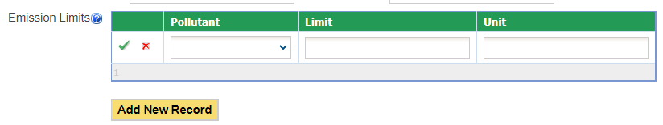

Figure 39 Emission Limit Table

Select the pollutant for which the emission limit will be requested using the drop-down menu. Then, indicate the emission limit and the units of measure in the following text boxes. To save the emission limit to the table, click on the green “checkmark” button. To cancel adding an emission limit to the table, click on the red “x” button.

Once you have entered emission limits to the list and confirmed it with the green “checkmark”, you may edit the equipment using the “pencil and paper” icon, or delete the record using the red “x” icon shown below in Figure 40. If you choose to delete the record, the Iowa EASY Air system will confirm with you that you want to delete the record with a pop-up message. Select “Ok” on this message to confirm, or “Cancel” to stop the deletion request.

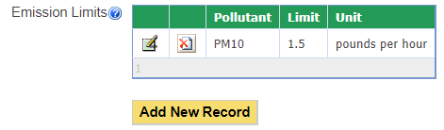

Figure 40 Emission Limit Table Example

**Other Limits:** Any other type of limit may be specified here.

**Rationale for Requested Limit:** If requesting a permit limit(s), indicate the rationale for the requested limit. If you are not sure about a requested operating limit, contact the Air Quality Bureau at 1-877-AIR-IOWA.

**Process and Air Emissions Diagram:** Provide a description of the process explaining both how the material flows through this emission unit and how air emissions will flow through the emission point connected to this emission unit. Include product input and output, fuel throughput, and any parameters which may impact air emissions.

You must attach an Air Emissions Diagram in the Attachments section of the application for each emission unit form included in the application, labeled “Form EU-13A”. The diagram should include what raw materials or products enter and exit the emission unit, how they flow through the emission unit, fuel usage which occurs at the emission unit, and any other material or product that flows into and out of the emission unit. In addition, show the pathway of air emissions from each emission unit through each piece of control equipment (if any) to the emission point. Identification numbers used in the diagram should be consistent with the labeling of EU IDs, CE IDs and EP IDs used through this application. An example of an Air Emissions Diagram is shown below in Figure 41.

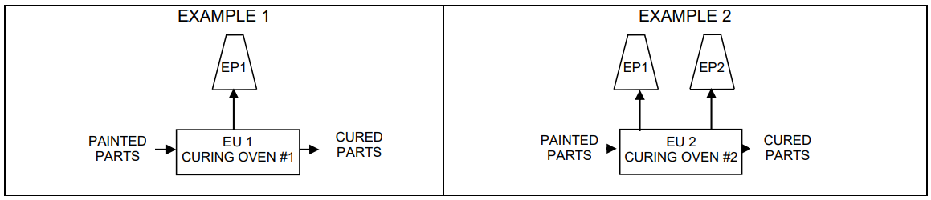

Figure 41 Air Emissions Diagram (Form EU-13A) Example

#### Cooling Tower

**Number of Cells in Tower:** Provide the number of cells in this cooling tower.

**Tower Maximum Water Flow Rate**: Provide the total maximum water flow rate of this cooling tower and the units of measure used to describe that flow rate (e.g. gallons per minute or gallons per hour).

**Measured TDS Content**: If data is available, provide the maximum Total Dissolved Solids (TDS) content of the water.

**Additives in the Water:** Indicate if any additives are used in the water (biocide, chromium, anti-corrosion agents, etc.), and provide a Safety Data Sheet (SDS) for each additive in the Attachments section of the application. The SDS can be obtained from the additive supplier.

**Mist Eliminators:** Indicate if there are any mist eliminators for this cooling tower. The mist eliminator(s) should be associated as a control equipment and saved as a Control Equipment form.

**Operating Limits (TDS Limits):** If you are requesting a Total Dissolved Solids (TDS) limit, please indicate this in units of parts per million (ppm).

#### Boiler

**Maximum Hourly Nameplate Capacity (heat input):** Enter the boiler’s maximum hourly nameplate capacity (MMBtu/hr heat input). The maximum hourly capacity should be read from the boiler’s nameplate or can be obtained from the manufacturer. Please ensure you are providing the boiler heat input and not heat output.

**Serial Number:** Provide the serial number of the boiler, if known.

**Date Boiler was Manufactured:** This is the date the boiler was built by the manufacturer.

**Oxygen Trim System:** Is the boiler equipped with an oxygen trim system to maintain an optimum fuel-to-air ratio in the boiler? An oxygen trim system is a system of monitors that is used to maintain excess air at the desired level in a combustion device over its operating load range. A typical system consists of a flue gas oxygen and/or carbon monoxide monitor that automatically provides a feedback signal to the combustion air controller or draft controller. This information should be available from the boiler manufacturer.

**For Coal Boilers Only:** Identify the type of coal to be burned in the boiler.

**For Solid Fuel Boilers Only:** If you intend to burn a solid fuel in this boiler, provide an ultimate and a proximate analysis representative of the fuel you intend to burn and include these in the Attachments section of the application. These analyses can be obtained from the fuel supplier.

**Operating Limits (Quantity of Fuel Burned):** If you are requesting a Quantity of Fuel Burned limit, please indicate this in units such as gallons per year or scf per year.

**Operating Limits (Fuel Material Content Limits):** If you are requesting a Fuel Material Content limit, please indicate this in units such as percentage of sulfur in the fuel. Include a unit of measure for this requested limit.

**Fuel Burned Component List:** Indicate the fuel type used by the boiler by clicking on “Add New Fuel Burned Component”. The following screen should appear as shown in Figure 42:

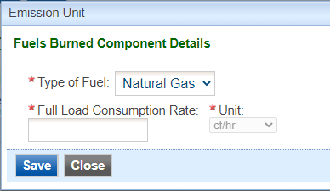

Figure 42 Boiler Fuel Burned Component Example

Select the type of fuel using the drop-down menu. For each type of fuel, the Iowa EASY Air system will require additional details specific to that fuel. Explanations for the fields for each type of fuel are listed below:

**Natural Gas:** Provide the full load consumption rate, which is the fuel consumption rate at the boiler’s maximum rated capacity, in units of cubic feet (cf) per hour.

**Fuel Oil:** Provide the full load consumption rate, which is the fuel consumption rate at the boiler’s maximum rated capacity, in units of gallons per hour. Additionally, provide the fuel oil number (#) and sulfur content (in units of percent by weight or parts per million (ppm)) of the fuel.

**Wood:** Provide the full load consumption rate, which is the fuel consumption rate at the boiler’s maximum rated capacity, in units of pounds per hour.

**Coal:** Provide the full load consumption rate, which is the fuel consumption rate at the boiler’s maximum rated capacity, in units of pounds per hour. Additionally, provide the sulfur content (in units of percent by weight or parts per million (ppm)) of the coal.

**Other Fuels:** Provide the fuel type, along with the full load consumption rate, which is the fuel consumption rate at the boiler’s maximum rated capacity. Specify the units from the options of gallons per hour, pounds per hour, cubic feet per hour, tons per hour, or MMBtu per hour. Additionally, provide the sulfur content (in units of percent by weight or parts per million (ppm)) of the fuel.

Once you have finished entering information for the fuel component burned, click on “Save” to add the component to the table. You may view or edit the component using the “pencil and paper” icon, or delete the record using the red “x” icon. If you choose to delete the record, the Iowa EASY Air system will confirm with you that you want to delete the record with a pop-up message. Select “Ok” on this message to confirm, or “Cancel” to stop the deletion request.

#### Internal Combustion Engine

**Use of Engine:** Check all that apply:

**Non-emergency:** Engine used as a primary power source for equipment. Also, an engine used to provide peaking power, back-up power, or standby power. Engines used in curtailment programs or load management are considered non-emergency engines.

**Emergency:** Engines only operated in emergency situations or for required testing and maintenance. An emergency is an unforeseeable condition beyond the control of the owner or operator. See definitions in 40 CFR §60.4219 and in 40 CFR §60.4248 for examples.

**Black start:** An engine with the sole purpose of starting a combustion turbine.

**Emergency with local reliability:** Emergency engines also used to support the electrical grid if required by local power transmission and distribution system operator. Local reliability is not the same as curtailment or load management.

**Fire pump:** An emergency engine certified to NFPA requirements to provide power to pump water for fire suppression or protection.

**Engine’s Rated Power:** Provide the rated power in brake horsepower, kilowatts, or MMBtu per hour. The rated power of the engine should be read from the engine’s nameplate or manufacturer literature. If the engine is connected to an electrical generator, use the rating for the engine and not the generator.

**Engine Ignition Type:** Engines that burn diesel fuel oil are compression ignition (CI) engines. Engines that burn other fuels are spark ignition (SI) engines. Dual fuel engines are considered CI engines.

**Model Year:** The calendar year that the engine was built or the annual new model production period of the engine manufacturer.

**Date Engine was Manufactured:** This is the date the engine was built by the manufacturer.

**For CI Engines:** For a CI engine, enter the displacement per cylinder in liters. This is the displacement of one cylinder, not the engine’s total displacement.

**For SI Engines:** Indicate whether the engine’s combustion cycle is **2-stroke or 4-stroke**.

**For SI engines:** Indicate whether the engine is **rich burn or lean burn**. For rich burn engines, the recommended operating air/fuel ratio divided by the stoichiometric air/fuel ratio at full load is less than or equal to 1:1.

**Engine’s Crankcase Ventilation:** Indicate if the engine has an open crankcase ventilation system or a closed crankcase. An open crankcase vents blowby gases to the atmosphere; a closed crankcase vents the blowby gases back to engine’s intake manifold.

**Certified to an EPA Tier Standard:** Since 1996, EPA requires manufacturers of new engines to meet certain emission standards, called Tiers. If the engine is certified to an EPA Tier Standard, select the Tier No. from the dropdown menu. The engine’s Tier number can be obtained from the engine’s manufacturer or dealer.

Starting in 2007, all new CI engines must be certified. If the engine is certified, please include the following information with the application in the Attachments section:

**The Certificate of Conformity:** this is a certification from EPA to the engine manufacturer that the engine complies with the Tier Standard; and

**Manufacturer’s technical information**: If the engine is not certified, include the manufacturer’s technical information on the engine.

**Operating Limits:** If you wish to have permit limits placed on the emission unit, mark “Yes.” Then, provide the requested limit in the units of operating hours per year or gallons of fuel burned per year. If you are not sure about a requested operating limit, contact the Air Quality Bureau at 1-877-AIR-IOWA.

**Fuel Burned Component List:** Indicate the fuel type used by the internal combustion engine by clicking on “Add New Fuel Burned Component”. The following screen should appear as shown in Figure 43:

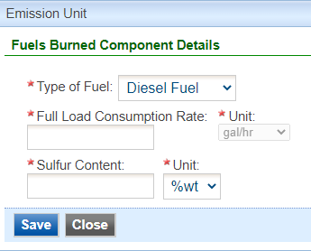

Figure 43 Engine Fuel Burned Component Example

Select the type of fuel using the drop-down menu. For each type of fuel, the Iowa EASY Air system will require additional details specific to that fuel. If the engine is a dual-fuel engine, add all appropriate fuel types to this form (e.g. natural gas and diesel). Explanations for the fields for each type of fuel are listed below:

**Diesel Fuel:** Provide the full load consumption rate, which is the fuel consumption rate at the engine’s maximum rated capacity, in units of gallons per hour. Additionally, provide the sulfur content (in units of percent by weight or parts per million (ppm)) of the fuel.

**Gasoline Fuel:** Provide the full load consumption rate, which is the fuel consumption rate at the engine’s maximum rated capacity, in units of gallons per hour.

**Natural Gas:** Provide the full load consumption rate, which is the fuel consumption rate at the engine’s maximum rated capacity, in units of cubic feet (cf) per hour.

**Other Fuels:** Provide the fuel type, along with the full load consumption rate, which is the fuel consumption rate at the engine’s maximum rated capacity. Other fuels would include: propane, digester biogas, or landfill gas. Specify the units from the options of gallons per hour or cubic feet per hour. Additionally, provide the sulfur content (in units of percent by weight or parts per million (ppm)) of the fuel.

Once you have finished entering information for the fuel component burned, click on “Save” to add the component to the table. You may view or edit the component using the “pencil and paper” icon, or delete the record using the red “x” icon. If you choose to delete the record, the Iowa EASY Air system will confirm with you that you want to delete the record with a pop-up message. Select “Ok” on this message to confirm, or “Cancel” to stop the deletion request.

#### Nonmetallic Mineral Processing Plant

**Equipment List:** Indicate whether you will attach an equipment list to the application. If providing an equipment list, please label the attachment “EU2-1A” and provide the following information for each equipment: Date of On-Site Installation, Emission Unit (EU) ID, Emission Unit Name, Emission Unit Description, Construction Date, Modification Date, and Maximum Rated Capacity. Provide the name of all the equipment at your plant that generates fugitive emissions only. **Fugitive emissions** means particulate matter not collected by a capture system and is released to the atmosphere at the point of generation. The equipment includes, but is not limited to: each crusher, grinding mill, screener, belt conveyor, bucket elevator, bagging operation, storage bin, enclosed truck, or railcar loading station.

**Emission Unit Description:** For each piece of equipment, provide a description. For example: jaw crusher, supply belt, Simplicity screener, cone crusher, etc. Provide manufacturer’s name if known.

**Construction Date*:** Provide the date of original construction for the equipment emission unit. In the case of proposed construction, provide the best estimate of construction commencement. For the purpose of this form, **Construction** means fabrication, erection, or installation of any new equipment or control equipment that would result in a change in emissions. If you don’t know the month, use January 1st of the known year.

**Modification Date*:** Provide the date of modification for the equipment emission unit. In the case of proposed modification, provide the best estimate of modification commencement. For the purpose of this form, ***Modification*** means any physical change or change in the method of operation of any existing equipment or control equipment. If you don’t know the month, use January 1st of the known year.

* Month/day/year should be provided for equipment that began construction in 1983 and in 2008. For any other year, only the year is required.

**Maximum Rated Capacity**: Indicate the maximum rated capacity of the equipment. Use tons per hour for a crusher, grinding mill, bucket elevator, bagging operation, enclosed truck, or railcar loading station; use the total surface area of the top screen for a screening operation; use the width for a conveyor belt; and use tons for a storage bin.

#### Spray Paint Booth

**Spray Gun Descriptions and Specifications:** Please provide information on the spray gun(s) used in the booth. Add a new record for each gun in the booth. To add a record to the Table, click on “Add New Record”. In the table provide the following information (See Figure 44):

**Manufacturer:** Specify the manufacturer(s) of the spray gun(s) used in your paint booth.

**Model:** Specify the model(s) of the spray gun(s). Model information can be obtained from the manufacturer or vendor.

**Gun Type:** Indicate the type of the spray gun(s). The type can be airless, conventional, electrostatic, or HVLP. The type of spray gun can be obtained from the manufacturer or vendor.

**Transfer Efficiency Percentage:** Indicate the transfer efficiency of the painting operation in percent. Transfer efficiency is the ratio of the amount of coating solids deposited on the surface of the material coated to the total amount of coating solids sprayed. It is dependent on several factors including the type of material coated, the type of spray gun used, and the efficiency of the person applying the spray material. For estimates of transfer efficiency, please refer to your spray gun manufacturer or vendor, or Appendix E in the DNR guidance document [Estimation of Emissions for Form EC](http://www.iowadnr.gov/Environmental-Protection/Air-Quality/Construction-Permits/Construction-Permitting-Materials#258770-general-guidance).

**Maximum Rated Capacity:** The rated capacity is the maximum spray rate of the spray gun(s).

**Units:** Provide the units of measure used to describe the Maximum Rated Capacity (e.g. gallons per minute, ounces per minute, etc.).

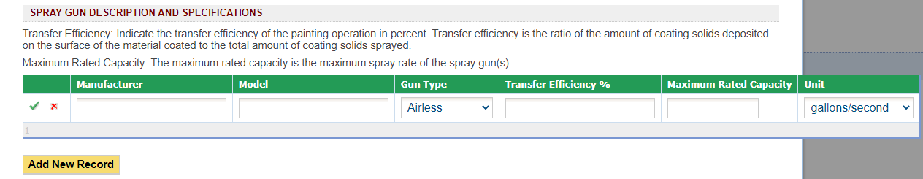

Figure 44 Spray Gun Description and Specifications Table

To save the spray gun to the table, click on the green “checkmark” button. To cancel adding a spray gun to the table, click on the red “x” button.

Once you have entered your spray gun(s) to the list and confirmed it with the green “checkmark”, you may edit the equipment using the “pencil and paper” icon, or delete the record using the red “x” icon. If you choose to delete the record, the Iowa EASY Air system will confirm with you that you want to delete the record with a pop-up message. Select “Ok” on this message to confirm, or “Cancel” to stop the deletion request.

**Number of Guns:** Specify the number of the spray guns used *simultaneously* in the paint booth.

**Spray Material and Specifications:** Please provide information on the spray materials used in the booth. A new record should be created for each spray material used in the booth. To add a record to the Table, click on “Add New Record”. In the table provide the following information (See Figure 45):

**Type of Material Used**: Specify all the spray (coating) materials used in this paint booth (i.e. enamel, lacquer, clean-up solvent, primer, etc.).

**Type of Material Coated**: Indicate all the types of materials being coated in this paint booth (i.e. metal, wood, plastic, etc.).

**Solid Content**: Indicate the maximum solid content for each coating material used in the paint booth in pounds per gallon as specified in the product specification sheets or Safety Data Sheet (SDS). SDS and product specifications can be obtained from your paint manufacturer or vendor.

**VOC Content**: Indicate the maximum volatile organic chemicals (VOC) content for each coating material used in the paint booth in pounds per gallon as specified in the product specification sheets or Safety Data Sheet (SDS). SDS and product specifications can be obtained from your paint manufacturer or vendor.

**SDS Attached**: The Safety Data Sheet (SDS) or product specification sheets for each coating material used in the spray paint booth should be attached with the application. The SDS must contain the total VOC content, a listing of each ingredient, and the weight percent of these ingredients.

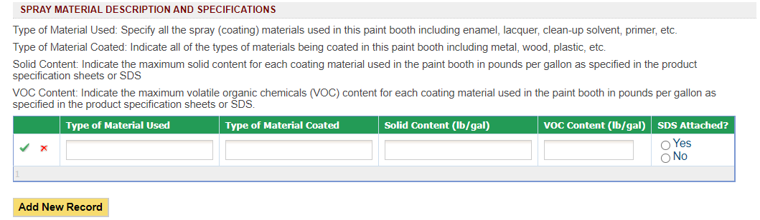

Figure 45 Spray Material Description and Specifications Table

To save the spray material to the table, click on the green “checkmark” button. To cancel adding a spray material to the table, click on the red “x” button.

Once you have entered your spray material(s) to the list and confirmed it with the green “checkmark”, you may edit the equipment using the “pencil and paper” icon, or delete the record using the red “x” icon. If you choose to delete the record, the Iowa EASY Air system will confirm with you that you want to delete the record with a pop-up message. Select “Ok” on this message to confirm, or “Cancel” to stop the deletion request.

**Spray Material Compounds:** Indicate if any of the coating materials used in the paint booth contain any of the listed compounds (chromium, lead manganese, nickel, or cadmium). Refer to your SDS or product specification sheet for a listing of all compounds contained in the listed spray materials.

**Control Equipment:** Indicate if dry filters are used. If dry filters are used, please complete the dry filter control equipment form. If control equipment other than a dry filter system is installed on this spray paint booth, indicate “No” and complete the appropriate control equipment form.

**Operating Limits (VOC or HAP Content Limits):** Provide a quantitative value of the limit you are requesting for the content of the materials. This should be in percent by weight, pounds per gallon, or pounds per pound of solids applied.

**Material Usage Limits:** Provide a quantitative value of the limit you are requesting for material usage for the spray paint booth(s). A new record should be created for each material usage limit requested for the booth(s). To add a record to the Table, click on “Add New Record”. In the table provide the following information (See Figure 46):

**Material:** Provide the material you are limiting (i.e. paint, solvent, etc.).

**Limit:** The quantitative value of the limit (i.e. 1,000).

**Unit:** Indicate the units for the limit in the table (i.e. gallons/year, gallons/hour, lb/hour, or tons/year).

**VOC, Single HAP, and Total HAP Content Limits:** Provide the quantitative value of the limit you are requesting for the content of the materials. This should be in percent by weight, pounds per gallon, or pounds per pound of solids applied.

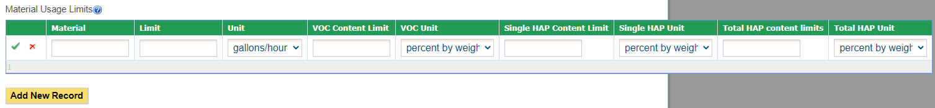

Figure 46 Material Usage Limits Table

To save the material usage limit to the table, click on the green “checkmark” button. To cancel adding a material usage limit to the table, click on the red “x” button.

Once you have entered your material usage limit(s) to the list and confirmed it with the green “checkmark”, you may edit the record using the “pencil and paper” icon, or delete the record using the red “x” icon. If you choose to delete the record, the Iowa EASY Air system will confirm with you that you want to delete the record with a pop-up message. Select “Ok” on this message to confirm, or “Cancel” to stop the deletion request.

#### Associating Control Equipment

To complete the emission unit form, please associate the emission unit with the appropriate control equipment (if applicable) by clicking on “Associate Control Equipment”. The previously completed control equipment table will appear, as shown below in Figure 47:

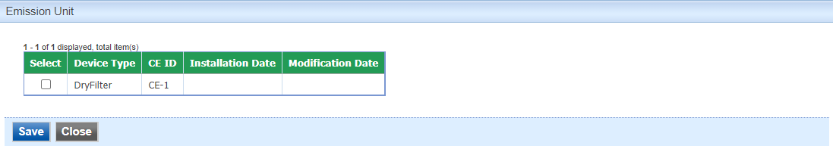

Figure 47 Associate Control Equipment Screen

Please select the control equipment that the emission unit will be controlled by, and then select “Save” to add this information to the emission unit form.

#### Associating Emission Points

To complete the emission unit form, please associate the emission unit with the appropriate emission point by clicking on “Associate Emission Point”. The previously completed emission point table will appear, as shown below in Figure 48:

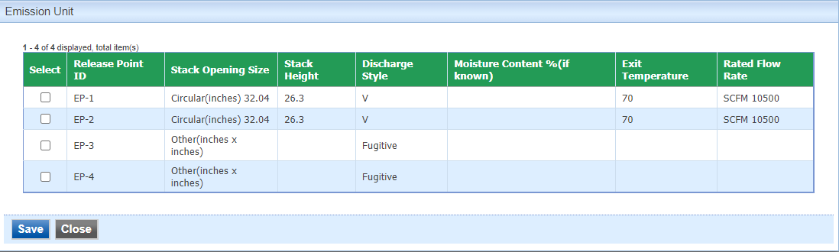

Figure 48 Associate Emission Point Screen

Please select the emission point(s) that the emission unit will vent to, and then select “Save” to add this information to the emission unit form. Please click “save” at the bottom of the screen to save the control equipment to the application.

It is recommended that you save after entering in each control equipment to prevent losing your progress. If you do not click “save” before loading into another page, you will lose your current progress entering information.

#### Modifying Existing Emission Units

To modify existing emission units that are in the system, find the Emission Unit ID in the table. If the emission unit is not in the table, use “Add New Emission Unit” and follow the instructions above.

When modifying existing emission units, check the “Include in Submittal” checkbox in the emission unit table (See Figure 49). This will highlight the emission point in red to indicate that it is included in the application, as shown below. Then, don’t forget to click the save button on the main Emission Unit screen. A green check mark will appear to confirm that the data is saved. To modify the emission unit information, click the “pencil and paper” icon under “View/Edit”, then follow the instructions above for entering emission unit information.

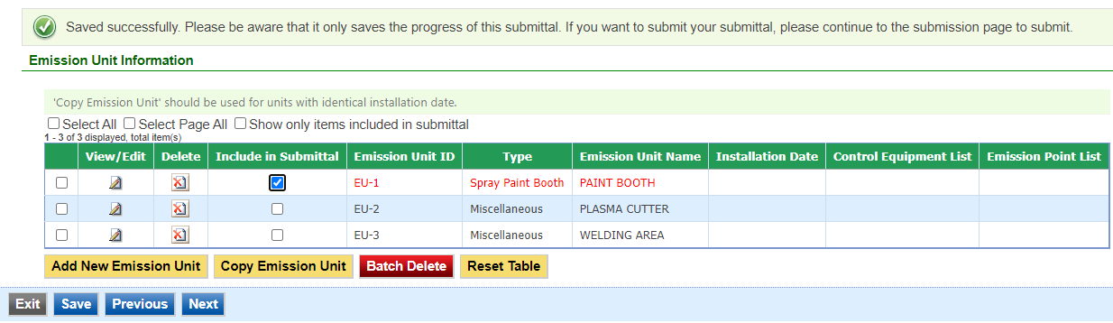

Figure 49 Emission Unit Modification Example

#### Deleting Emission Units

If you need to delete an emission unit, use the red “x on paper” icon to remove the equipment from the table. A pop-up warning will appear to confirm that you would like to delete the emission unit.

Do not delete emission units from this table that exist at the facility but are not a part of the application, as this will remove them from your facility inventory.

#### Copying Emission Units

Copying emission units can be useful to save time when entering in emission unit information for similar or identical units. The copy emission unit function should only be used for equipment with identical installation dates. To copy an emission unit entry, select the emission unit you would like to copy in the first column of the table using the checkbox and click the “Copy Emission Unit” button (See Figure 50).

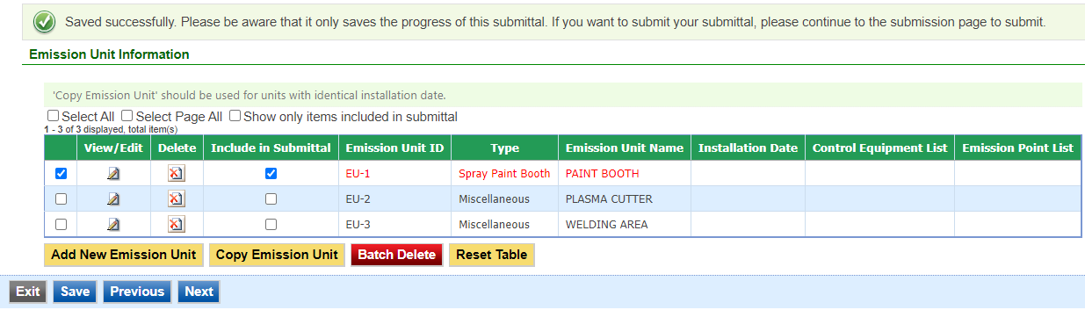

Figure 50 Copying an Emission Unit Entry Example

A new screen will pop up to enter in a new emission unit ID and emission unit name, as shown below in Figure 51. Use the instructions above in the New Emission Units section for the description for the ID and emission unit name.

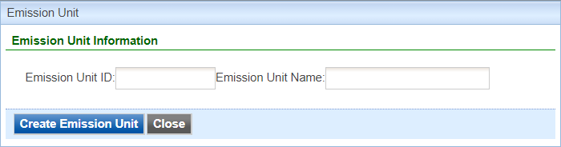

Figure 51 Copying an Emission Unit Entry Example

When you have finished entering the information for the copy of the emission unit, click “Create Emission Unit”. This will create a copy of the emission unit in the emission unit table, but will not save it to the table. Click on the “Include in Submittal” checkbox and then click “Save” at the bottom of the screen to save it to the emission unit table. If you need to modify any aspect of the newly created emission unit entry, use the “pencil and paper” icon to edit the emission unit.

#### Other Emission Unit Functionality

At the top of the emission unit table, there will be three checkboxes by default: “Select All”, “Select Page All”, and “Show only items included in submittal”.

Clicking on “Select All” will check the checkbox in the first column of the table for **all** emission unit entries, even if they are on a different page. Clicking on “Select Page All” will check the checkbox for all emission unit entries on the current page (if there are multiple pages). These two functions can be used with the “Batch Delete” button at the bottom of the page to simplify deleting multiple emission units.

Clicking on “Show only items included in submittal” will display only the emission units that have been marked as “Include in Submittal” within the emission unit table. This can be useful if there are multiple pages of emission units for a facility, where only one or two emission units are being modified.

Clicking on “Reset Table” will reset the emission unit table to be based on the information originally pulled from the State & Local Emissions Inventory System (SLEIS).

It is not recommended to use this function, since there may have been multiple modifications made to the specific emission units since the information was originally pulled from SLEIS.

#### Finishing Up

The emission unit table should include all emission units affected by the application, even if the emission unit characteristics are not specifically being changed.

For example, if you are modifying control equipment monitoring parameters but the emission unit controlled by that equipment is not affected by the change, the emission unit information for that equipment should still be included even if the characteristics are unchanged.

Once you have finished entering the information, click “Save” and then “Next”.

## Emission Calculations

Next the Emission Calculations screen will appear. Please provide emission calculations for **EACH** emission point included in the submittal. This form provides information on the amount of regulated emissions that could be emitted from the emission point. Additional information on how to complete emission calculations can be found at the document titled [Estimation of Emissions: Recommended Methods for Completion of the Construction Permit Application Form EC](https://www.iowadnr.gov/portals/idnr/uploads/air/insidednr/conpermit/estimation_methods_form_ec.pdf), located on the DNR’s website.

#### Adding New Emission Calculation Information

To add new emission calculation information, use the “Add New Emission Calculations” button (see Figure 52).

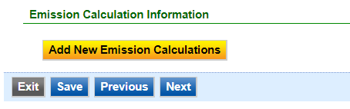

Figure 52 Add New Calculations Button

An Emission Calculation Detail Information screen will appear to enter the information for the control equipment (see Figure 53).

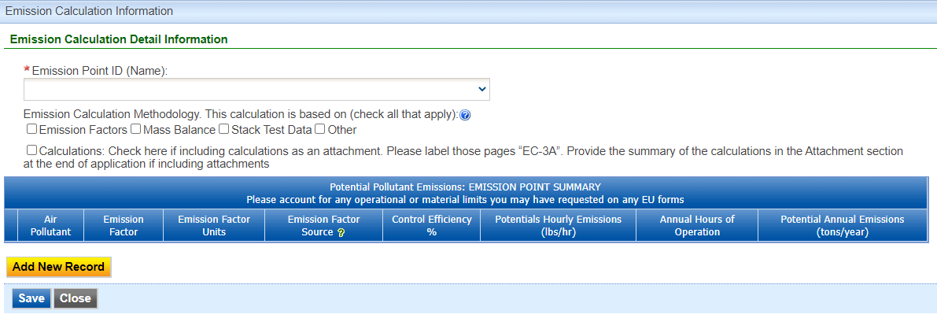

Figure 53 Emission Calculation Information Data Entry Example

Please select the applicable emission point ID from the drop-down menu under “Emission Point ID (Name)”.

* If you are including the emission calculation information as an attachment later in the application, you may select the checkbox directly below the emission point ID field. When including emission calculations as an attachment, label the pages as “EC-3A”. If you select this checkbox, no further information will be required for this form. After selecting the emission point ID and clicking on the checkbox, click “Save” on the screen and then click “Save” on the Emission Calculations form.

Next, select the Emission Calculation Methodology from the checkboxes on this form (check all that apply). A description for each of the methodologies is listed below:

**Emission Factors:** Emission factors generally represent industry averages and show the relationship between quantity of emissions and the production rate. Sources of EPA or State-Approved emission factors are best described in the DNR’s document [Estimation of Emissions: Recommended Methods for Completion of the Construction Permit Application Form EC](https://www.iowadnr.gov/portals/idnr/uploads/air/insidednr/conpermit/estimation_methods_form_ec.pdf), located on the DNR’s website.

**Mass Balance:** This approach may only be used on specific types of emission units. Information must first be gathered on process rates, material used, and material properties (usually from safety data sheets (SDS) sometimes also referred to as MSDS). By combining this information with the knowledge of the process, an emission estimation can be made.

**Stack Test Data:** A stack test measures the concentration of pollutants in the exhaust stack during the test period and converts the concentration to a mass measurement using the flow measured during the test period. Stack test data can provide an accurate source-specific emission rate for many different processes and pollutants under the testing conditions measured.

**Other:** “Other” can include Continuous Emissions Monitoring System (CEMS) data, vendor supplied emissions factors or emissions data, or engineering estimation.

* Continuous Emissions Monitoring System (CEMS) directly measure pollutant concentrations in the exhaust stack 24 hours a day. When combined with a flowmeter it can also convert the concentration into an accurate mass measurement. This is the most accurate method for determining continuous actual emissions.
* Vendor supplied emissions factors or emissions data may be used if stack test information or EPA-approved emissions factors are not available. This data should only be used to calculate emissions if the manufacturer’s data is based on approved EPA reference method stack testing and no significant changes have been made to the emission unit. Many times, vendor estimates of emissions do not correlate to the pollutants required to be documented on the construction permit application because vendors use alternative methods to test emissions.
* Engineering estimation is allowed if a more preferred method is not available. Some processes may have no published guidance regarding the estimation of emissions. In these cases, the estimation must be the best possible assessment given the amount of data available.

In all cases outside of EPA or State-Approved Emission Factors, supporting documentation must be provided with the application that shows how the estimation was made. Please provide the supporting documentation in the “Attachments” section of the application.

Next, include the potential pollutant emissions in the emission point summary table, as shown above in Figure 54. To add new information to this table, use the “Add New Record” button. The pollutant search field will appear, as shown below.

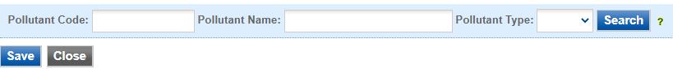

Figure 54 Pollutant Code Search Field

Please refer to section 3.4.11 (Associating Controlled Pollutants) of this document for an explanation of the pollutant codes. Once you have selected the appropriate pollutant, click on the checkbox for the pollutant and select “Save” to add it to the summary table as shown in Figure 55.

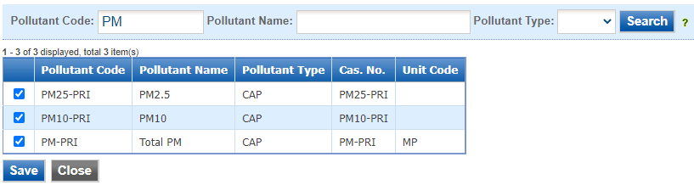

Figure 55 Pollutant Code Search Results

Once you have added a pollutant, the air pollutant will appear in the summary table. Please complete the fields for each column in the summary table. A description of each column is listed below for reference.

**Emission Factor:** Enter the numerical emission factor (in pounds per unit of measure) used to calculate the

potential emissions from this emission unit. The emission factor may also be expressed in terms of grains per standard cubic feet, or grains per dry standard cubic feet.

**Emission Factor Units:** Enter the emission factor units of measure. Typical emission factor units of measure are expressed in pounds of pollutant emitted per unit of production or unit of fuel combusted. Examples are

pounds/ton, pounds/gallon, pounds/million cubic feet, etc.

**Emission Factor Source:** Indicate the emission factor source from the list below:

* CEMS
* Stack Test
* Material Balance
* US EPA (WebFIRE, AP-42, TANKS, etc.)
* State or Local Speciation Profile
* Trade Group
* Vendor Data
* Manufacturer’s Specification
* Site Specific

**Control Efficiency %:** If there is control equipment installed on the emission point, enter the percent control efficiency. Ensure the control efficiency corresponds to the specific air pollutant.

**Potential Hourly Emissions (lbs/hr):** Calculate and provide the hourly controlled emissions from the emission point. If the emission point does not have any control, list the uncontrolled emissions in this box.

**Annual Hours of Operation:** List the hours per year the emission point will operate. Annual hours of operation should be 8760 hours unless requesting a permit limit on the number of hours the emission point will operate each year.

**Potential Annual Emissions (tons/year):** Calculate the annual potential emissions by multiplying the **Potential Hourly Emissions** by the **Annual Hours of Operation** and converting pounds per year to tons per year.

When you have finished entering the required information into this table, select “Save” on the far-left column to commit the information to the table. If you are missing required information, the system will not allow you to save the entry to the table. To cancel adding a pollutant, select “Cancel”. Once the information has been committed to the table, you may edit the information using the “pencil and paper” icon, or delete the information using the red “x” icon. Once you have added all the emission calculation information for each air pollutant, select “Save” on the screen and then click “Save” on the Emission Calculations form. Repeat these steps for **EACH** emission point included in the submittal.

Once you have finished entering the information, click “Save” and then “Next”.

## Emission Inventory

Next the Emission Inventory screen will appear as shown in Figure 56. This form provides information on total emissions at a facility that is used to classify the plant into the appropriate categories for the PSD and Title V programs.

Please note that the emission inventory form is completed per application, and it will not be saved to your facility for future use.

* If you would like to provide the Emission Inventory form as an attachment, select “Yes” under the question. No further information is required on this screen. Please attach your Emission Inventory document in the “Attachments” section of the application. Select “Save” on this screen and then select “Next”.

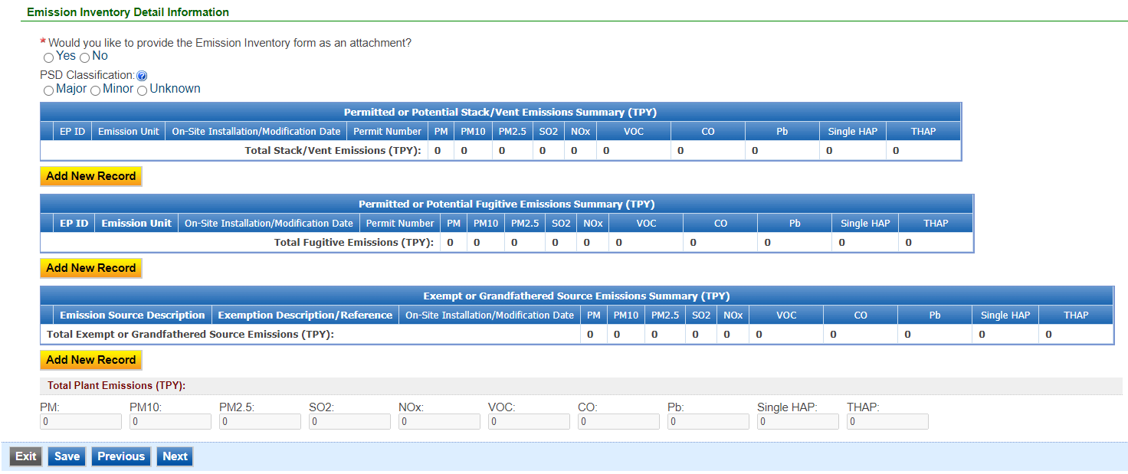

Figure 56 Emission Inventory Screen Example

Next, indicate whether your facility is a Major or Minor source for the Prevention of Significant Deterioration (PSD) program using the radio buttons. If previous construction permits have been issued to the facility, the classification may be found by referring to the most recent cover letter accompanying the issued construction permits. If you have not had permits issued to your facility or you do not know the PSD classification of your facility, please check “Unknown” and your classification will be determined during the review of the application.

* For a minor or unknown PSD source, list all emission points at your plant.
* For an existing major PSD source, you may list only the emission points that are new or were modified during the 5 years prior to this application.
* Ensure you include emissions from exempt and grandfathered units in this emission inventory as they can count towards Title V and PSD applicability.

#### Permitted or Potential Stack/Vent Emissions Summary

To add a record to the permitted or potential stack/vent emissions summary, select “Add New Record” as shown in Figure 57.

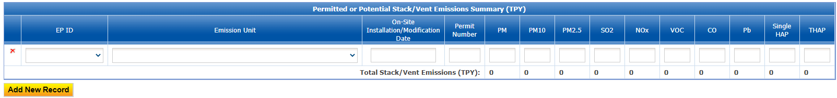

Figure 57 Emissions Summary Example

Please complete the information in the table. Instructions for each field is listed below for reference:

**EP ID:** Called the emission point (EP) identification (ID). Use the drop-down menu to select the appropriate emission point from the facility inventory. If multiple emission units use a common emission point, fill in the emission point ID in the EP ID column. List all emission units involved in the emission unit column below that emission point (EP) ID.

**Emission Unit:** Use the drop-down menu to select the appropriate emission unit from the facility inventory. The emission units will include both the emission unit (EU) identification (ID) and emission unit description.

**On-Site Installation/Modification Date:** Provide the date (both month and year) in which on-site installation or modification of the emission unit begins or will begin. For the purpose of this form, Modification means any physical change or change in the method of operation of any existing equipment or control equipment. If you don’t know the month, use January 1st of the known year.

**Permit Number:** Provide the permit number for the emission point.

**Potential or Permitted Emission Rate:** Summarize the potential or permitted emission rates for each air pollutant listed below for this emission point (stack or vent) in units of tons per year (TPY). “Potential to Emit” means the maximum capacity of a stationary source to emit pollutants under its physical and operational design. Any physical or operational limitation on the capacity of a source to emit pollutants shall be treated as part of its design if the limitation or the effect it would have on emissions is federally enforceable. These limitations may include: control equipment; restrictions on hours of operation; or restrictions on the type or amount of material combusted, stored, or processed. An applicant should base potential to emit on any requested emission limits; emission limits imposed by regulation; or by a process’ physical limitation.

* **PM:** All particulate matter (equivalent to total suspended particulate matter).
* **PM10:** Particulate matter with an aerodynamic diameter of ten microns or less, as measured by an EPA approved reference method.
* **PM2.5:** Particulate matter with an aerodynamic diameter of 2.5 microns or less, as measured by an EPA approved reference method.
* **SO2:** Sulfur dioxide.
* **NOX:** Nitrogen oxides.
* **VOC:** Photochemical reactive volatile organic compounds.
* **CO:** Carbon monoxide.
* **Pb:** Elemental lead and lead-containing compounds.
* **Single HAP:** The single hazardous air pollutant with the largest potential to emit at the plant. If more than one HAP is emitted at this plant please provide a summary of each HAP and their emissions at the plant.
* **THAP:** Total hazardous air pollutants.

**Total Stack/Vent Emissions (TPY):** The system will automatically sum all entries in this table to calculate the total for the stack/vent emissions.

To remove an entry in the Stack/Vent Emissions Summary, the Fugitive Emissions Summary, or the Exempt or Grandfathered Emissions Summary table, click the red “x”. The Iowa EASY Air system will confirm with you that you want to delete the record with a pop-up message. Select “Ok” on this message to confirm, or “Cancel” to stop the deletion request. Next, click “Save” at the bottom of the screen to save your progress on this form.

If you do not click “save” before loading into another page, you will lose your current progress entering information.

#### Permitted or Potential Fugitive Emissions Summary

Next, include permitted or potential fugitive emissions for your facility, if necessary. Fugitive emissions are those emissions that cannot reasonably be made to pass through a stack or vent or equivalent opening. Examples include coal piles, paved and unpaved roads, equipment leaks, etc. Fugitive emissions must be included on this form if:

* Your fugitive emission sources are quantifiable;
* Your plant is one of the 28 named source categories found in PSD rules in 40 CFR 52.21;
* Your emission unit is of the source category regulated by a NSPS (40 CFR Part 60) or NESHAP (either 40 CFR Part 61 or Part 63) standard that was promulgated as of August 7, 1980;
* Your plant has been determined to be major for PSD.

If none of the above applies to your submittal, you do not have to include fugitive emissions. If you are including fugitive emissions, follow the instructions for the stack/vent emissions summary table to enter information.

Next, click “Save” at the bottom of the screen to save your progress on this form.

If you do not click “save” before loading into another page, you will lose your current progress entering information.

#### Exempt or Grandfathered Source Emissions Summary

Next, include any exempt or grandfathered source in the third table.

* “Grandfathered” equipment refers to any piece of equipment or control equipment that emits any regulated pollutant that has not been constructed, modified, reconstructed, or altered after September 23, 1970. This also includes sources that only emitted volatile organic compounds (VOC) that were installed prior to April 22, 1987; however, the lack of emission limits on these sources may now subject these units, and even the entire facility, to additional regulations.
* If an emission point is covered by an exemption, provide the exemption being claimed for the emission unit by referencing the Iowa Administrative Code (e.g. 567 IAC 22.1(2)”…”).

Follow the instructions for the stack/vent emissions summary table to enter information (with the exception that you will not select the specific emission point or emission unit from the facility inventory – you will need to enter these sources manually).

The system will sum all the plant emissions in the section at the bottom labeled “Total Plant Emissions (TPY)”. Next, click “Save” at the bottom of the screen to save your progress on this form.

If you do not click “save” before loading into another page, you will lose your current progress entering information.

Once you have finished entering the information, click “Save” and then “Next”.

## Greenhouse Gas Emission Inventory

Next, the Project Greenhouse Gas Emission Inventory Information screen will appear as shown below in Figure 58.

As required by IAC 455B.134(3)”f”, Form GHG is required for every construction permit application even if the potential GHG emissions are zero.

GHG emissions are caused by combustion sources (e.g. dryers, boilers, space heaters, etc.). If your application does not have any Greenhouse Gas (GHG) emissions, please check the corresponding box at the top of the screen. The rest of the form does not need to be completed.

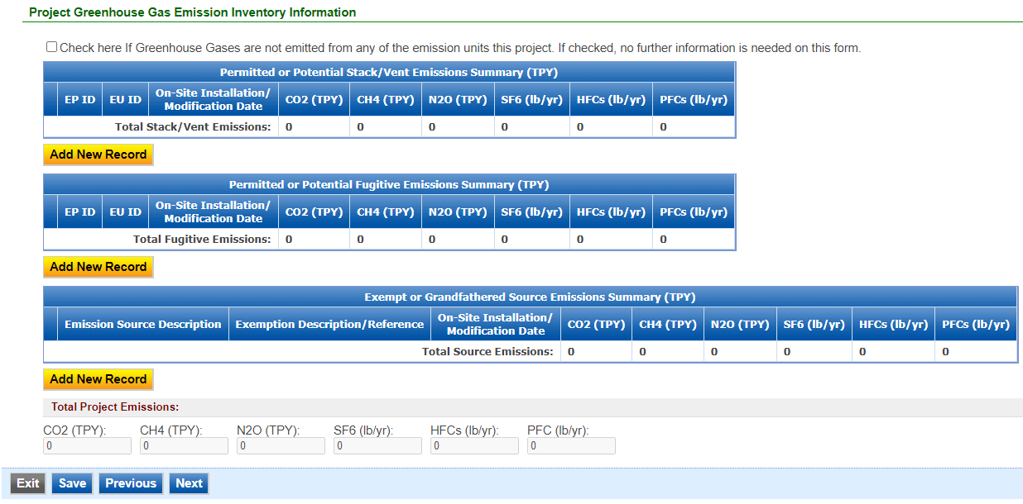

Figure 58 Project Greenhouse Gas Emission Inventory Information Summary

If GHG emissions are present:

* To begin entering information for each emission unit, use the “Add New Record” button.
* List ALL emission units in the project including fugitive sources, exempt units, and other non-permitted emission units (i.e. natural gas boilers rated less than 10 MMBtu/hr, chillers, small units, etc.). Mobile sources (i.e. trucks, forklifts, cars, etc.) are not required to be listed.
* Emission units may be grouped into categories (i.e. chillers, space heaters, etc.).
* If the project is a modification to an emission unit, the facility shall report the total GHG emissions for the unit.
* If multiple emission units use a common emission point, associate the emission point ID in column (1) to each of the emission units involved in column (2). Provide the GHG emissions for each unit venting to that emission point.
* Show how potential GHG emissions were calculated on an attached sheet labeled “Form GHG-A”. Total HFCs and PFCs are to be listed in the corresponding cells, but the calculations should separate the individual HFCs and PFCs.
* More information concerning GHG emissions, including emission factors, can be found on the Air Quality Bureau [Greenhouse Gas Emission page](https://www.iowadnr.gov/Environmental-Protection/Air-Quality/Greenhouse-Gas-Emissions).

The tables should be entered in the same manner as the emission inventory form. An explanation of the types of greenhouse gases is listed below.

**Potential or Permitted Emission Rate:** Fill in the rate of potential emission in the appropriate units (either tons per year or pounds per year) for each pollutant. The following are the GHG emissions that must be included:

* **CO2:** Carbon dioxide
* **CH4:** Methane
* **N2O:** Nitrous oxide, also known as dinitrogen oxide or dinitrogen monoxide.
* **SF6:** Sulfur hexafluoride
* **HFC:** Hydrofluorocarbons
* **PFC:** Perfluorocarbons

**Attach a copy of your calculations showing how the potential GHG emissions were calculated in the “Attachments” section, labeled “Form GHG-A”.** Total HFCs and PFCs are to be listed in the corresponding cells, but the calculations should separate the individual HFCs and PFCs. If you have more stack/vent emission sources than can fit on this form, attach a separate sheet labeled “Form GHG-A”.

**For PSD applications only:** CO2e emissions must also be calculated and attached on a separate sheet labeled “Form GHG-A”. CO2e emissions are defined as the sum of the mass emissions of each individual GHG adjusted for each pollutant’s global warming potential (GWP). Guidance on calculating CO2e is available on the [**GHG Estimation Tools**](http://www.iowadnr.gov/Environmental-Protection/Air-Quality/Greenhouse-Gas-Emissions/GHG-Estimation-Tools).

There is a separate field area for fugitive emissions on this screen. Fugitive emissions are those emissions that cannot reasonably be made to pass through a stack or vent or equivalent opening. Examples include equipment leaks, portion of landfill gas emissions, portion of wastewater treatment plant emissions, transformers, etc. Fugitive emissions must be included on this form if they are part of the current project for which the application is being submitted.

The system will automatically sum all the potential or permitted emission rates for the listed equipment. To remove an entry in the Stack/Vent Emissions Summary, Fugitive Emissions Summary, or the Exempt or Grandfathered Emissions Summary table, click the red “x”. The Iowa EASY Air system will confirm with you that you want to delete the record with a pop-up message. Select “Ok” on this message to confirm, or “Cancel” to stop the deletion request. Please click “save” at the bottom of the screen to save the data entered into each table to the application.

If you do not click “save” before loading into another page, you will lose your current progress entering information.

Once you have finished entering the information, click “Save” and then “Next”.

## Non-PSD Modeling Determination

Next the Non-PSD Modeling Information screen will appear. This form is optional. The Non-PSD Modeling Determination form is used to help determine whether an air dispersion modeling analysis will be required for non-PSD construction permit projects (including non-PSD projects at PSD-major facilities). This procedure is used for both newly installed construction permit projects and for modifications to previous projects.

Some unique circumstances not addressed by this form may trigger a modeling review. These include,

but are not limited to:

* Projects located at facilities associated with non-attainment or maintenance areas for the pollutant(s) in question;
* New facilities locating in an already industrialized area where a majority of the air quality resource is already being utilized;
* New or modified portable plants;
* New sources with lead emissions, or increases in lead emissions from existing sources;
* Relaxation of permit limits or requirements originally established to protect the National Ambient Air Quality Standards (NAAQS);
* Changes to source location, stack design or facility layout; or
* Direct ozone emissions.

Indicate on the form whether you would like to determine if a modeling analysis will be required.

* If you answer “No”, no further information is needed on this form. Select “Save” on this screen and then select “Next”.

The DNR will review each project to determine the need for modeling outside the scope of this form. For assistance determining if additional modeling may be required for your project contact the Construction Permit Helpline at 1-877-AIR-IOWA, or call the DNR at 515-725-8200 and ask to speak to a member of the Air Quality Bureau’s dispersion modeling team.

If you indicated “Yes”, please fill out the required information in Figure 59 as shown below. An explanation of the fields in the table are listed below for reference.

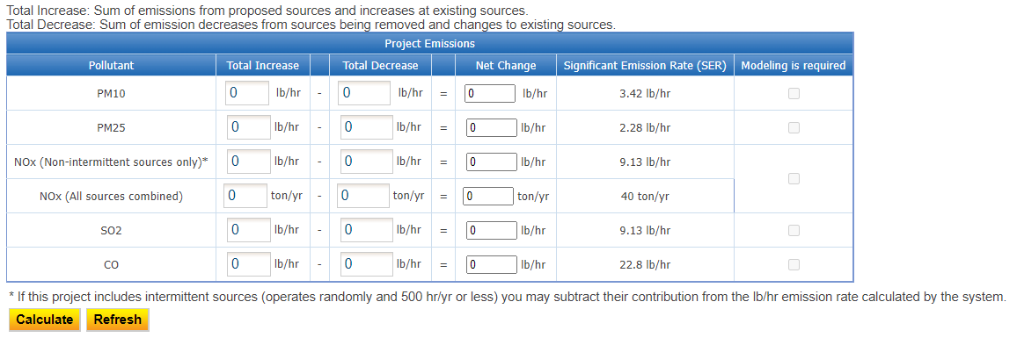

Figure 59 Non-PSD Modeling Information Example Screen

**Pollutants:** The pollutants to be evaluated for potential modeling, including:

* **PM10:** Particulate matter with an aerodynamic diameter of ten microns or less, as measured by an EPA-approved reference method.
* **PM2.5:** Particulate matter with an aerodynamic diameter of 2.5 microns or less, as measured by an EPA-approved reference method.
* **NO2:** Nitrogen dioxide, a subset of NOX or all oxides of nitrogen.
  + Fill in the emissions for “non-intermittent sources” and “all sources combined.” Per the Department’s [Air Dispersion Modeling Guidelines for non-PSD, Pre-Construction Permit Applications](https://www.iowadnr.gov/Portals/idnr/uploads/air/dispmodel/modeling_guidelines.pdf), “intermittent sources” are those that operate randomly, and for 500 hours per year or less. A source is still considered intermittent if test/maintenance is not random as long as it occurs between 9 am and 4 pm.
  + “All sources combined” are all sources included in this application.
* **SO2:** Sulfur dioxide.
* **CO:** Carbon monoxide.

**Total Increase:** Add together the following for each pollutant:

* For equipment **proposed to be installed** as a part of this application or for **existing equipment that should already have had a construction permit** and is being permitted as a part of this application, the increase in emissions is:
  + The requested emission limit or maximum calculated emission rate. These numbers can be found on the Emissions Calculations screen, **plus**,
* For equipment that **already has a permit** and is being modified as a part of this application or for **equipment that did not previously need a permit** (e.g. previously used a permit exemption or was not required to be permitted) and is being permitted as a part of this application, the increase in emissions is determined from one of the three options below:
  + If requesting an increase in the permitted emission limit, use the difference between the current permitted emission limit and the new requested emission limit. The requested emission limit can be found on the Emission Unit or Emission Calculations screen. The previously permitted emission limit can be found in the existing construction permit.
  + If the equipment currently has a permit and was previously modeled at the permitted emission limit and no change is requested to the limit as a part of the application, the applicant may assume zero increase in emissions for that equipment. The applicant can determine if the equipment was previously modeled and the emission rate at which it was modeled by reviewing the “Emission Limits” section of the existing construction permit.
  + If none of the above apply, use the difference in the best estimate of emissions at the maximum rated capacity of the equipment both **before** the change and **after** the change requested in the application. These numbers may be found on the Emission Calculations screen. If not calculated on the Emissions Calculations screen in this manner, they may need to be calculated separately for this form.

**Total Decrease:** Some projects may not have decreases or you may not want to quantify the decreases, in which case please put “zero” in this column. You may skip this section if the increases calculated do not exceed the Significant Emission Rate (SER – see below for the definition). Decreases to permitted emission limits without actual emissions reductions cannot be counted as decreases in this section.

**Add together** the following for each pollutant:

* For equipment which is being **removed** as a part of this application, the decrease in emissions is:
  + The permitted emission limit from the equipment being removed if previously modeled at the permitted emission limit. These numbers can be found in your existing construction permit, or
  + The best estimate of emissions at the maximum rated capacity of the equipment if not previously modeled, or if no permitted emission limit exists. These numbers most likely will need to be calculated separately for this form, **plus**,
* For existing equipment that is being **modified to decrease emissions** as a part of this application:
  + The difference in the best estimate of emissions at the maximum rated capacity of the equipment both **before** the change and **after** the change requested in the application. These numbers may be found on the Emission Calculations screen. If not calculated on the Emissions Calculations screen in this manner, they may need to be calculated separately for this form.

**Net Change:** The system will automatically calculate the net change from the Total Increase and Total Decrease values for each pollutant.

**Significant Emission Rate (SER):** A quantity of emissions more likely to cause concentrations that threaten the NAAQS. If the project’s emission rate for any pollutant is greater than or equal to the SER, modeling is required for that pollutant.

To determine if modeling is required, select “Calculate” or “Refresh” (if changes were made to the existing calculated values). The system will automatically determine if modeling is required based on the calculated net change compared to the SER.

Next, complete the required fields for the Availability of Air Resources table, as shown below in Figure 60. Only complete the following section for the Availability of Air Resources for pollutants with a net change in the Project Emissions section above that is **greater** than zero. This table should be left blank if the project is for a new facility or a portable plant. Due to the nature of these types of facilities, it is necessary for the DNR to determine the availability of air resources when the application is processed.

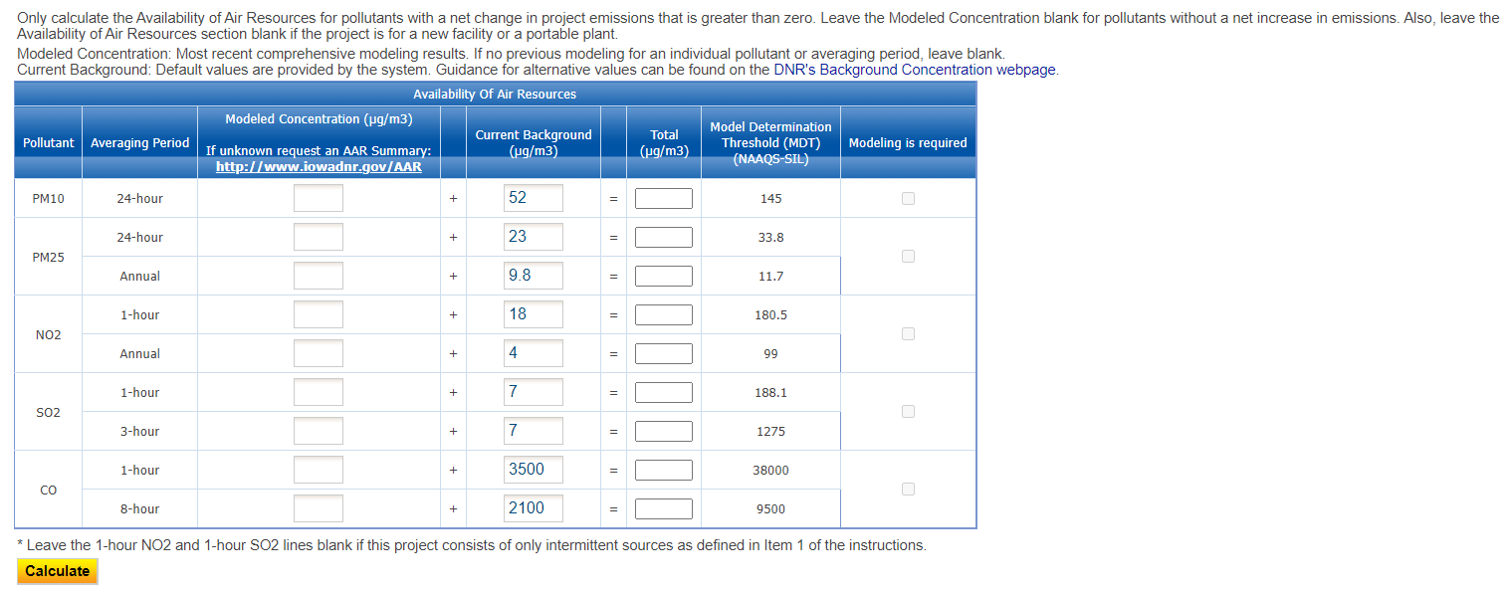

Figure 60 Availability of Air Resources Example Screen

An explanation of the fields in the table are listed below for reference.

**Pollutant:** The pollutants to be evaluated for potential modeling. See above for definitions.

**Averaging Period:** The period of time over which the average concentration of a pollutant is calculated. The averaging period(s) for given pollutants are set by EPA when NAAQS are developed, and range from 1-hour (acute) to annual (chronic).

**Modeled Concentration (µg/m3):** For each pollutant with a net change greater than zero in the Project Emissions section, it is important to calculate the air resource currently used in your project’s geographic area to determine if the NAAQS are threatened. If this application is for a new facility or a portable plant you may skip this section.

* Fill in the modeled concentration from the most recent comprehensive modeling analysis for each pollutant and averaging period listed. The most recent Availability of Air Resources (AAR) Summary for your facility may be used for this purpose. To request a copy of the AAR Summary visit the [Availability of Air Resources](https://www.iowadnr.gov/Environmental-Protection/Air-Quality/Availability-of-Air-Resources) webpage. If previous comprehensive modeling does not exist for an individual pollutant or averaging period leave it blank.
* Leave the Modeled Concentration blank for pollutants without a net increase in emissions.

**Current Background (µg/m3):** The background concentration includes naturally-occurring and human-produced pollutants that exist in the absence of the industrial emissions being evaluated as part of this project. The background concentration will change over time and must be reevaluated whenever an analysis is conducted. The EASY Air application will automatically display the background concentration for the county specified for the plant’s location on the Facility Information form. Alternatively, applicants can propose non-default background concentrations. If using a non-default background concentration, attach justification for the chosen value(s) to the EASY Air application. The DNR’s dispersion modeling team will review non-default background concentrations used for the purposes of this form (major sources will be subject to the current hourly rate for dispersion modeling for this review). In some cases, a time-varying background will be used in a modeling analysis. Time-varying background concentrations are those that fluctuate based on the time of year or time of day. These time-varying background concentrations are included in the modeled concentration and cannot be updated without reevaluating the modeling analysis. If a time-varying background was included in the modeled concentration, leave the background concentration blank.

**Total (µg/m3):** The EASY Air system will calculate the total of the modeled concentration and the background concentration after selecting the “Calculate” button at the bottom of the table.

**Modeling Determination Threshold (MDT) (NAAQS – SIL):** The MDT is equal to the NAAQS minus one Significant Impact Level (SIL). This is the threshold at which the NAAQS is considered to be threatened. A modeling analysis must be conducted to ensure the project will either result in a concentration less than the SIL, or that comprehensive modeling of the entire area will result in concentrations less than the NAAQS.

If the total concentration is greater than the MDT, the EASY Air system will indicate that modeling is required for that pollutant. The system will also summarize the modeling determination in the table shown below in Figure 61. A modeling analysis is required for each checked pollutant.

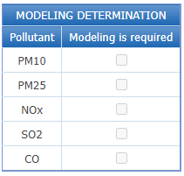

Figure 61 Modeling Determination Example Screen

If the checkbox is checked for “Modeling is required”, please indicate who will conduct the modeling analysis using the drop-down field.

All applicants have the option to prepare and submit a complete dispersion modeling analysis per DNR’s [Air Dispersion Modeling Guidelines for Non-PSD, Pre-Construction Permit Applications](https://www.iowadnr.gov/Portals/idnr/uploads/air/dispmodel/modeling_guidelines.pdf) and the [Dispersion Modeling Checklist for Non-PSD Projects](https://www.iowadnr.gov/portals/idnr/uploads/forms/5420470.pdf). If modeling will be submitted to the DNR, a significant impact analysis should be conducted for each pollutant requiring modeling. This analysis should include only the current project. If the project will cause predicted concentrations that exceed any Significant Impact Level (SIL), a comprehensive modeling analysis should be conducted for the applicable pollutant(s). The comprehensive analysis must demonstrate that the project will not cause or contribute to any predicted exceedances of the NAAQS. Refer to the Modeling Guidelines for additional details. Submitted modeling analyses will be reviewed by the DNR for accuracy and completeness.

Alternatively, the DNR will conduct the initial modeling analysis if the applicant requests it. The DNR may request that the applicant conduct a revised modeling analysis if the initial analysis indicates that extensive project design changes will be necessary in order to meet the NAAQS. When this occurs the DNR will provide the applicant with a summary of the initial modeling analysis along with all associated modeling files. For major sources (defined in 567 IAC—22.100), time that the DNR spends reviewing or conducting the modeling analysis in support of the permit application will be subject to the current major source application fee. For non-major sources, the modeling analysis is included in the minor source application fee.

If you select “I will submit the modeling analysis for the DNR’s review”:

* Include [Form MI-1](https://www.iowadnr.gov/Portals/idnr/uploads/forms/5420949.pdf) (plot plan) in the permit application or the modeling analysis report, which may be attached in the Attachments section. Applicants can also provide [Form MI-2](https://www.iowadnr.gov/Portals/idnr/uploads/forms/5420950.pdf) (source characteristics), or equivalent, which may help expedite the analysis. If Form MI-2 is not provided the DNR will use the most current available information for sources that are not part of the project. Applicants may contact the DNR to request the most recent modeling files to use as a starting point.

If you select “I request that the DNR conducts the initial modeling analysis”:

* Include [Form MI-1](https://www.iowadnr.gov/Portals/idnr/uploads/forms/5420949.pdf) (plot plan) with the permit application, which may be attached in the Attachments section. Applicants may choose to also provide [Form MI-2](https://www.iowadnr.gov/Portals/idnr/uploads/forms/5420950.pdf) (source characteristics), or equivalent, which may help expedite the analysis. If Form MI-2 is not provided the DNR will use the most current available information for sources that are not part of the project (if necessary).

**Tips for When Modeling is Not Required**

Even if modeling is not required it is still important to consider the potential impact of the project on the air quality resources in the area. Future projects may trigger a comprehensive modeling analysis in which the sources in this project would need to be included. Designing the sources to comply with the National Ambient Air Quality Standards (NAAQS) now can help prevent modifications at a later date. The following tips will help minimize the impact on the air quality resources in your area:

* Use pollution controls to reduce overall emissions.
* Build stacks with vertical, unobstructed-type discharges. Hinged stacks, hexagonal stacks, and stack-in-a-stack style rain guards are considered unobstructed-type discharges.
* Locate stacks as far as possible from the facility’s property boundary.
* Build stacks as tall as possible.

Some applicants may find it beneficial to perform a modeling analysis even if they are not required to submit it with the permit application. Doing so will help ensure that the chosen design complies with the NAAQS. In addition, having an up-to-date comprehensive model on file can help applicants plan for, and thus expedite, future projects. Modeling analyses that are conducted outside the scope of the requirements listed in this form do not need to be submitted to the DNR, and should not be used to complete the Availability of Air Resources section of this form.

Once you have finished entering the information, click “Save” and then “Next”.

## Form AF (Application Fee)

Next the Form AF (Application Fee) screen will appear if the “Billing Status Selected” is “Major Source – Hourly Fee” as shown in Figure 62. This form is not required if the “Billing Status Selected” is “Minor Source – Fee Per Application”.

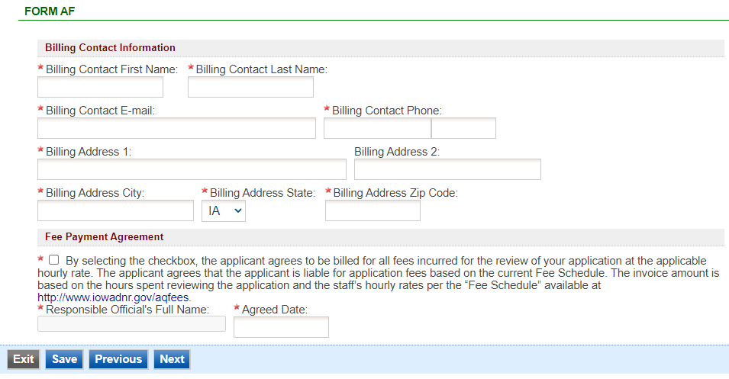

Figure 62 Form AF Screen

If this form is applicable, please enter the contact information for the person who should be contacted regarding billing for the review of the application materials. Please review the fee payment agreement carefully and check the box indicating that you agree to be billed for all fees incurred for the review of your application at the hourly rate, then enter the Responsible Official’s Full Name and date. Once you have finished entering the information, click “Save” and then “Next”.

## Attachments

Next the Attachments screen will appear as shown in Figure 63. Please upload the required attachments to the application and any other attachments at this screen.

Attachments may be uploaded to the application electronically, or mailed/faxed to the Department.

The Iowa DNR recommends that attachments be submitted electronically so as to not slow down the application process.

Please attach any documents required to assist the assigned engineer with completing the project on this screen.

To include your attachment(s) in the Iowa EASY Air system, select the “Online” radio button and then click on the “Upload” button. Only one file may be uploaded at a time, and the maximum file size allowed is 100 MB. The example attachment screen shown below may appear differently depending on what was selected earlier in the application in the Form FI screen.

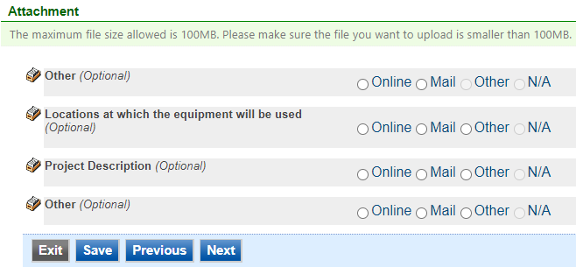

Figure 63 Example Attachment Screen

Select “Choose File” to select the document to be uploaded (see Figure 64). These file types are accepted by the system:

* pdf, doc, docx, txt, xls, xlsx, cvs
* jpeg, jpg, bmp, png, gif
* xml

You may include a comment for each attachment. When you have successfully selected the document, click on “Save” to upload the attachment.

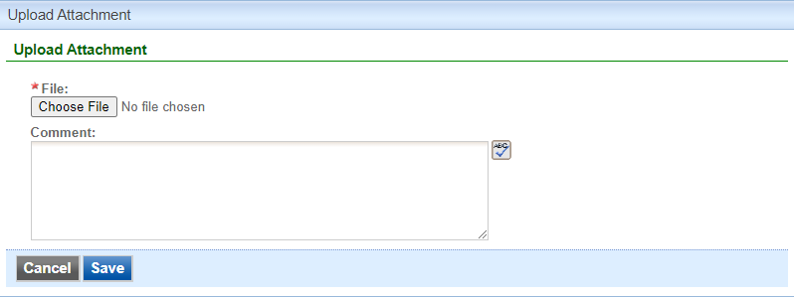

Figure 64 Upload Attachment Screen

The uploaded attachment will display on the screen (See Figure 65). To remove an attachment, click the red “x” icon. The Iowa EASY Air system will confirm with you that you want to delete the record with a pop-up message. Select “Ok” on this message to confirm, or “Cancel” to stop the deletion request. To edit the attachment comment, click on the attachment comment, edit the comment, then select “Save” to update the comment or “Cancel” to cancel the change.

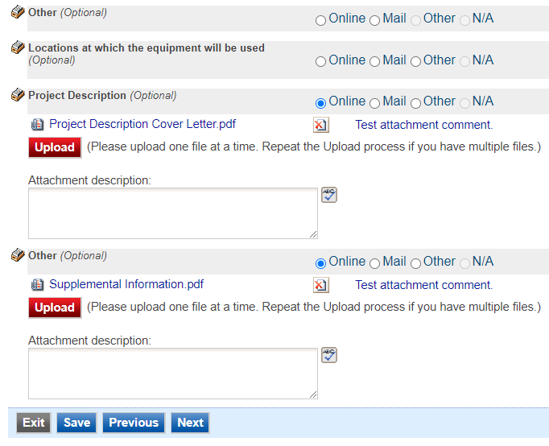

Figure 65 Example Attachment Screen

Please click “save” at the bottom of the screen to save the page.

If you do not click “save” before loading into another page, you will lose your current progress entering information.

If you plan to mail or fax the attachments, please select the “Mail” radio button on the attachment screen. If mailing attachments, include the attachment descriptions and submittal ID. Mail attachments to the following address:

Application Login Desk

Air Quality Bureau

502 E 9th Street

Des Moines, IA 50319

Please select “Other” if you wish to submit the document a different way, such as hand delivery, fax, or describe the reason in the comment text box. If faxing documents, include the attachment descriptions and submittal ID. The Air Quality Bureau fax number is (515) 725-9501.

## Validation

Next the Validation screen will appear. The system will check the application forms for required information that is missing, and will display a result similar to Figure 66 below:

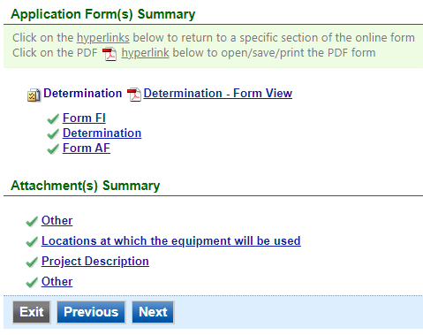

Figure 66 Example Validation Screen

If there are no noted issues, click the “Next” button. If there are issues, you may navigate to the section by selecting the section on this screen to complete the missing information.

Please note that the system will only check for missing information, and will not validate whether the information is complete or accurate.

## Payment

Next the Payment screen will appear if the “Selected Billing Status” on Form FI is “Minor Source – Fee Per Application” (See Figure 67). The application fee for a Minor Source permit is $385.00 per permitted emission point included in the application. You may pay for the application fee by Credit Card, Check, Money Order, or eCheck (ACH – NACHA).

The Iowa DNR recommends that payment be submitted electronically (Credit Card or eCheck) so as to not slow down the application process.

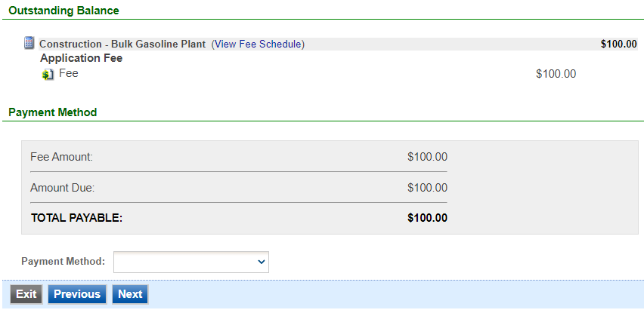

Figure 67 Example Payment Screen

If paying by Credit Card or eCheck, please use the “Online Checkout” option in the dropdown menu. The system will request the applicable information for each type of payment. If paying by Check or Money Order, select the appropriate method in the dropdown menu. When sending the payment via mail, please use the following information for payment:

* Pay To: Iowa Department of Natural Resources
* Address: Wallace State Office Building 502 E 9th St, 4th Floor, Des Moines IA 50319
* Please print a copy of the submittal receipt and mail it in with the payment or write the submittal ID number on the check or money order.

When you have finished, click the “Next” button.

## Submission

Next, the Certification of Submission screen will appear (See Figure 68). Please review the statement at the top of the screen, then check the box at the top of the screen, answer the security question, enter your pin, and click “Submit”.

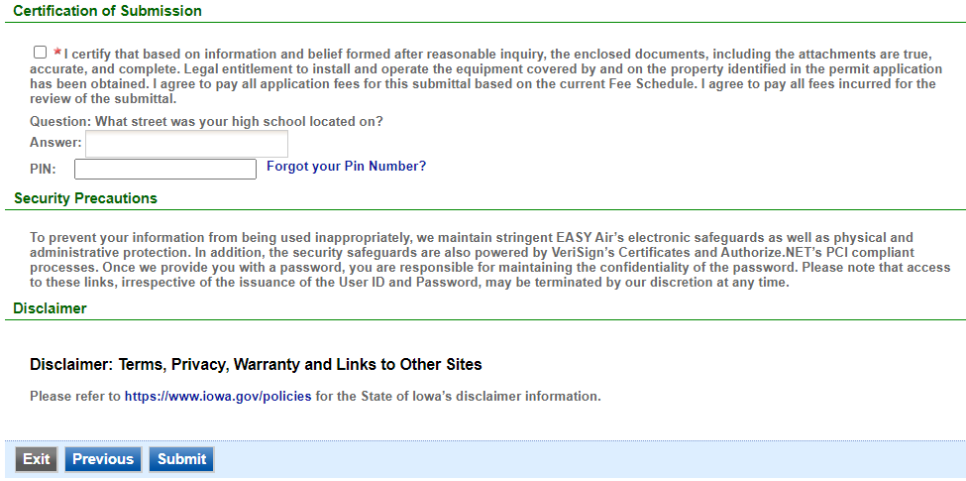

Figure 68 Example Certificate of Submission Screen

You will get a confirmation screen similar to the one shown below in Figure 69 and a confirmation email will be sent to you.

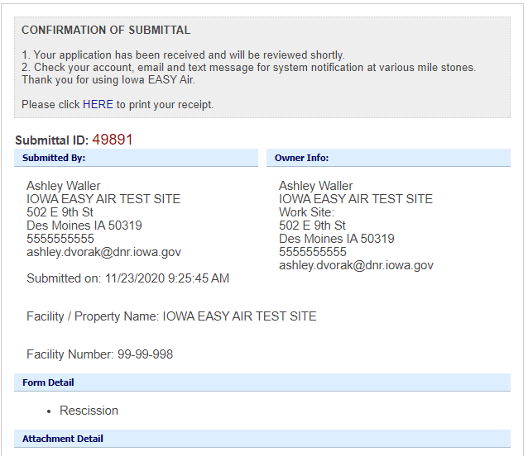

Figure 69 Confirmation of Submittal

**If you have questions, please call the Iowa EASY Air Helpdesk  
at (515) 725-9569 or (515) 204-3749.**

**Or, send an email to** [**easyair@dnr.iowa.gov**](mailto:easyair@dnr.iowa.gov)